EARTHEATER RELEASES NEW ALBUM

HEADLINE SHOWS IN
LOS ANGELES AND NEW YORK CITY THIS MONTH

HEAVENLY BODY: IF I’M THE BOTTLE YOU’RE THE MESSAGE OUT NOW
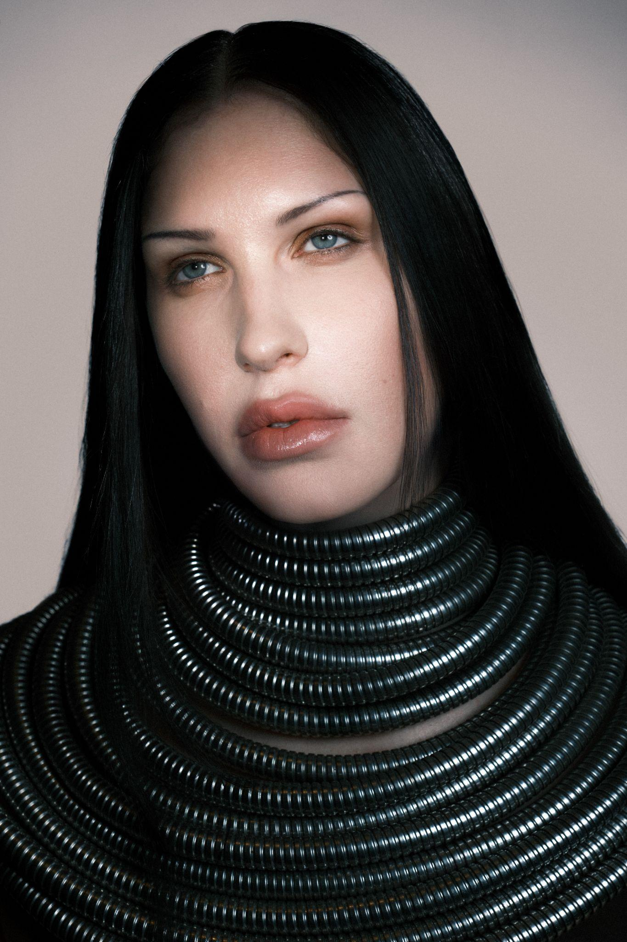
Eartheater by Vidar Logi

Heavenly Body: If I’m The Bottle You’re The Message
https://chemicalx.ffm.to/HeavenlyBody
VINYL PRE-ORDER: https://chemicalx.ffm.to/heavenlybodyvinyl

(July 14, 2026) - Experimental composer, singer, producer and multi-instrumentalist Eartheater, the alias of artist Alexandra Drewchin, releases her new album Heavenly Body: If I’m The Bottle You’re The Message today. The new album was fully produced by Eartheater and David Sitek (Yeah Yeah Yeahs, TV on the Radio, Jane’s Addiction), outside of the closing track “Nova,” which was co-produced with Nosaj Thing and Michael Andrews (Donnie Darko), and includes a feature from fellow new mother and lauded artist, Oklou.

Heavenly Body: If I’m the Bottle You’re The Message, is as personal as it is universally expansive, as everyday diaristic as it is mythopoetic. Exploring the pregnant body as a vessel for something greater than itself, it offers an intimate look at what it means to carry another human, how that transforms your body and life. It’s a gorgeous, complex record, one of birth plans and playlists, peeing in cups at doctor visits, and pregnancy sex. While it’s the singular experience of one woman, it also reflects feelings other people have experienced in other ways, without having to be a parent, which adds to the collection’s power.

Sonically, Heavenly Body’s a mix of dance lullabies, exhilarating post-wave bangers, prismatic electronic anthems, and stadium-stretching art-pop. Drewchin’s in the zone here, and these songs, finely detailed and deep, feel effortless. She started making Heavenly Body a little over three months after her now 10-month-old daughter, Nova, was born. Spending just a few months on a major work is remarkable. “It is very much born from the throws and blisses of becoming a mother. Some music can wait to come out and it will make sense whenever it does. This music had to come out immediately.” When you move quickly, you have less time to second-guess yourself and the 11 resulting tracks are some of Eartheater’s catchiest and most immediate. You can feel that energy in each word and in each note.

Eartheater practices her own strain of poetic alchemy. Shapeshifting between electronic experimentation and acoustic texture, Eartheater has long delved into themes of erosion and lithification, along with the infinite possibilities of metamorphosis. In October 2025, she celebrated the 10-year anniversary of her first two albums, Metalepsis and RIP Chrysalis, classics in experimental electronic music. She’s collaborated with a variety of artists, including FKA twigs, where she contributed the top-line melody, guitar playing, and production to the lead single for twigs’ Grammy-winning album EUSEXUA, modern music chamber ensemble Alarm Will Sound, Irish-Chilean electronic producer Sega Bodega, and British singer, DJ, and rapper Shygirl. Comfortable on large stages, in punk houses, and in museums, she also understands the fashion runway: Chanel has featured her music three times in their shows, as well as Dior, Proenza Schouler, and Mugler.

Tomorrow night, Eartheater begins her run of headline shows in Los Angeles ahead of hometown shows in New York City next week. This August, Eartheater will venture across the pond to Europe and the United Kingdom for shows in London, Paris, and Berlin. Full dates below and tickets on sale now HERE.
Listen to Heavenly Body: If I’m The Bottle You’re The Message above, see full album and show details below, and stay tuned for more from Eartheater coming very soon.

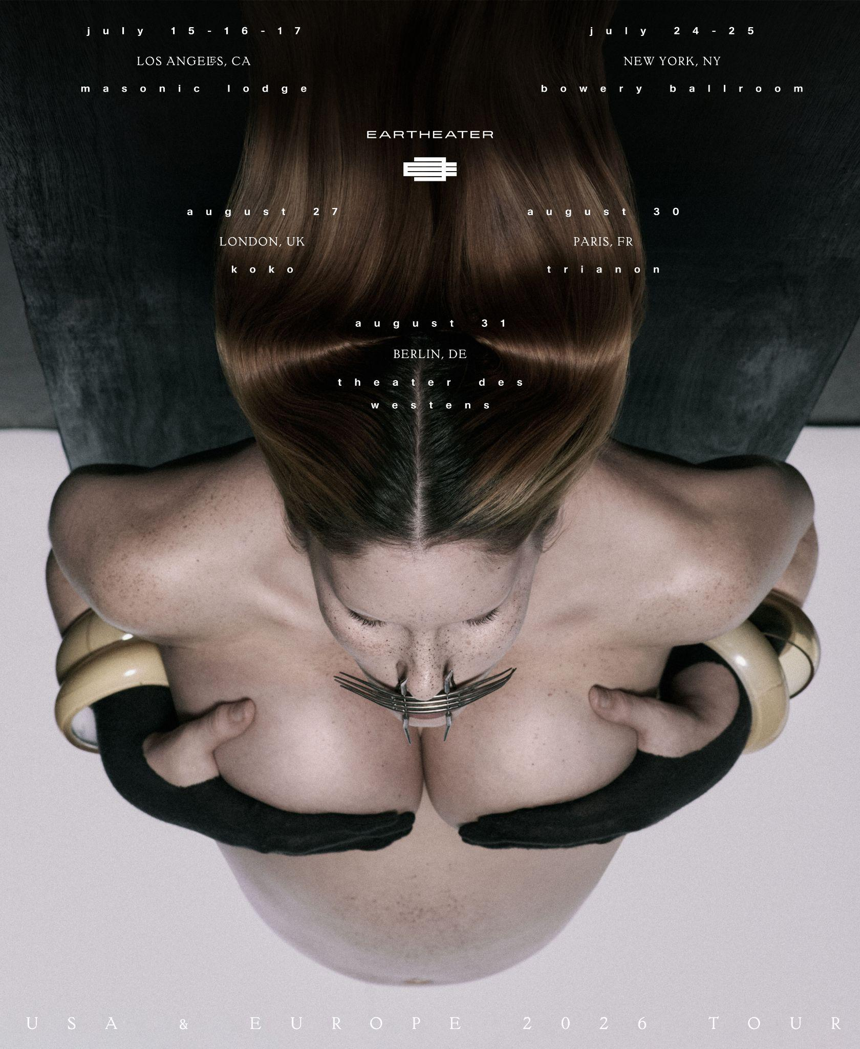

Upcoming Live Dates

7/15 - Los Angeles, CA @ Masonic Lodge at Hollywood Forever SOLD OUT
7/16 - Los Angeles, CA @ Masonic Lodge at Hollywood Forever SOLD OUT
7/17 - Los Angeles, CA @ Masonic Lodge at Hollywood Forever SOLD OUT
7/24 - New York, NY @ Bowery Ballroom
7/25 - New York, NY @ Bowery Ballroom
8/27 - London, UK @ Koko
8/30 - Paris, FR @ Trianon SOLD OUT
8/31 - Berlin, DE @ Theater des Westens

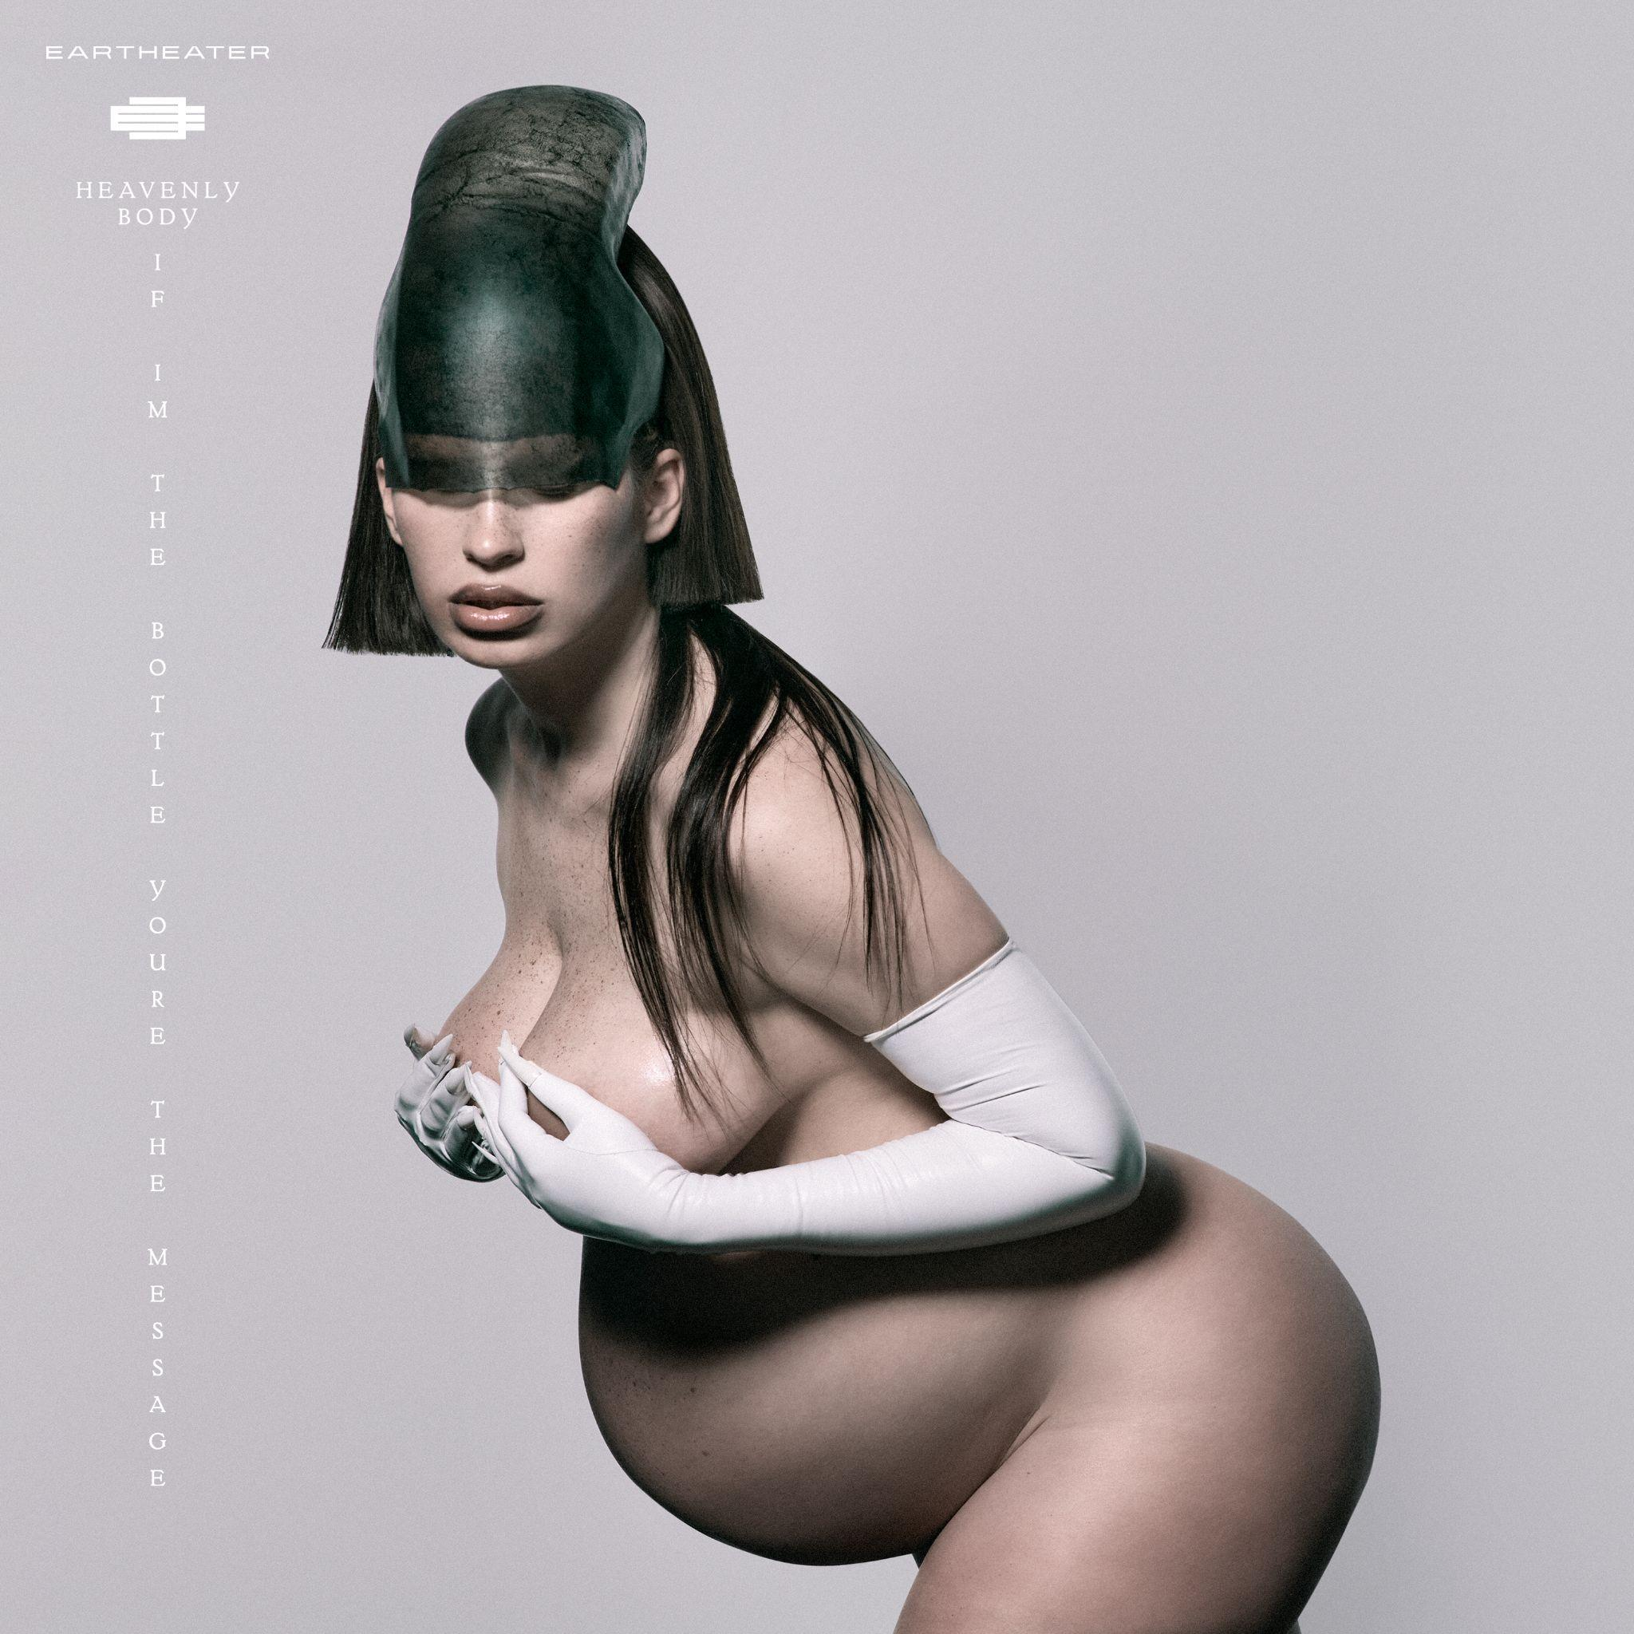
Heavenly Body: If I’m The Bottle You’re The Message album artwork

Eartheater
Heavenly Body: If I’m The Bottle You’re The Message
July 14th, 2026

1. Malka Moma
2. Paradise Rains
3. Practical Amnesia
4. Crown Jewel
5. Wasp in the Fig
6. Glowing Guts
7. Hers Before Hers
8. Don’t Look Back
9. Favorite
10. Fast Asleep (featuring Oklou)
11. Nova

﻿(Download hi-res assets HERE)

Connect with Eartheater
Instagram | X (Twitter) | Website

For all Eartheater inquiries, please contact Bradley Bledsoe or Alicia Cote at Orienteer:
bradley@orienteer.us | alicia@orienteer.us

