EARTHEATER ANNOUNCES NEW ALBUM

SHARES LEAD SINGLE “PARADISE RAINS”

ANNOUNCES HEADLINE SHOWS IN
LOS ANGELES AND NEW YORK CITY THIS JULY

HEAVENLY BODY: IF I’M THE BOTTLE YOU’RE THE MESSAGE OUT JULY 14 VIA CHEMICAL X
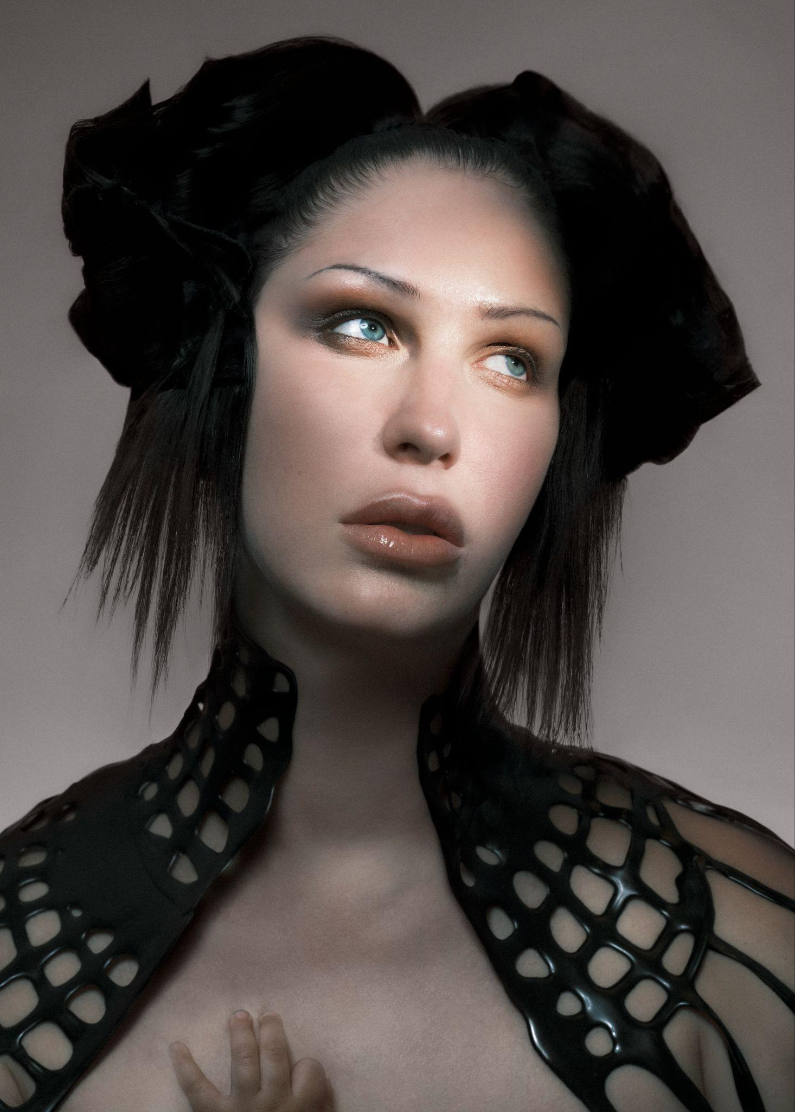
Eartheater by Vidar Logi

Heavenly Body: If I’m The Bottle You’re The Message
PRE-SAVE: https://chemicalx.ffm.to/HeavenlyBody

“Paradise Rains”
LISTEN:
https://chemicalx.ffm.to/paradiserains
WATCH : https://www.youtube.com/watch?v=_vkf22qnqTk&list=RD_vkf22qnqTk&start_radio=1

(May 13, 2026) - Composer, singer, producer, and multi-instrumentalist Eartheater, the alias of artist Alexandra Drewchin, announces her long awaited seventh album Heavenly Body: If I’m The Bottle You’re The Message due July 14th via Chemical X. Alongside the album announcement, Eartheater shares the lead single “Paradise Rains,” an enchanting ballad with cavernous production.

Speaking about the story behind the song Eartheater shares, “‘Paradise Rains’ is a song about buying back my childhood farm after being estranged from it for 20 years. I conceived my baby the day we first stepped back on the property. So many memories, good and bad, were resuscitated being back, and calloused tensions dissolved and got washed away by the showers of deep love with my new little family.”

Alongside the album announcement and new single, Eartheater announces headline shows in Los Angeles and New York City set to take place this July. Eartheater will then head across the pond to Europe and the United Kingdom for shows in London, Paris and Berlin. Full dates below and tickets on sale this Friday HERE.

Heavenly Body: If I’m the Bottle You’re The Message, is as personal as it is universally expansive, as everyday diaristic as it is mythopoetic. Exploring the pregnant body as a vessel for something greater than itself, it offers an intimate look at what it means to carry another human, how that transforms your body and life. It’s a gorgeous, complex record, one of birth plans and playlists, peeing in cups at doctor visits and pregnancy sex. While it’s the singular experience of one woman, they’re also feelings other people have experienced, in other ways, without having to be a parent — which adds to the collection’s power.

Sonically, Heavenly Body’s a mix of dance lullabies, exhilarating post-wave bangers, prismatic electronic anthems, and stadium-stretching art-pop. Drewchin’s in the zone here, and these songs, finely detailed and deep, feel effortless. She started making Heavenly Body a little over three months after her now 10-month old daughter, Nova, was born. Spending just a few months on a major work is remarkable. “It is very much born from the throws and blisses of becoming a mother. Some music can wait to come out and it will make sense whenever it does. This music had to come out immediately.” When you move quickly, you have less time to second-guess yourself and the 11 resulting tracks are some of Eartheater’s catchiest and most immediate. You can feel that energy in each word and in each note. Heavenly Body was fully produced by Eartheater and David Sitek (Yeah Yeah Yeahs, Jane’s Addiction, The Carters), outside of the closing track “Nova,” which was co-produced with Nosaj Thing and Michael Andrews (Donnie Darko), and includes a feature from fellow new mother and lauded artist, Oklou.

Eartheater practices her own strain of poetic alchemy. Shapeshifting between electronic experimentation and acoustic texture, Eartheater has long delved into themes of erosion and lithification, along with the infinite possibilities of metamorphosis. In October 2025, she celebrated the 10 year anniversary of her first two albums, Metalepsis and RIP Chrysalis, classics in experimental electronic music. She’s collaborated with a variety of artists including FKA twigs, where she contributed the top-line melody, guitar playing, and production to the lead single for twigs’ Grammy-winning album EUSEXUA, modern music chamber ensemble Alarm Will Sound, Irish-Chilean electronic producer Sega Bodega, and British singer, DJ, and rapper Shygirl. Comfortable on large stages, in punk houses, and in museums, she also understands the fashion runway: Chanel has featured her music three times in their shows as well as Dior, Proenza Schouler, and Mugler.
Pre-save Heavenly Body: If I’m The Bottle You’re The Message and check out “Paradise Rains” above, see full album details below, and stay tuned for more from Eartheater coming very soon.

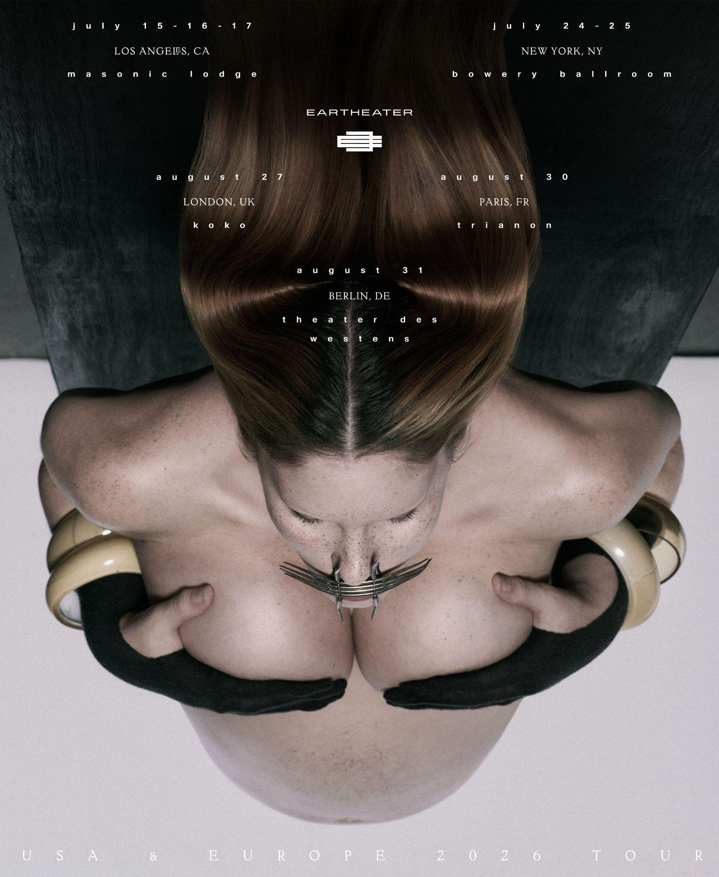

Upcoming Live Dates

7/15 - Los Angeles, CA @ Masonic Lodge at Hollywood Forever
7/16 - Los Angeles, CA @ Masonic Lodge at Hollywood Forever
7/17 - Los Angeles, CA @ Masonic Lodge at Hollywood Forever
7/24 - New York, NY @ Bowery Ballroom
7/25 - New York, NY @ Bowery Ballroom
8/27 - London, UK @ Koko
8/30 - Paris, FR @ Trianon
8/31 - Berlin, DE @ Theater des Westens

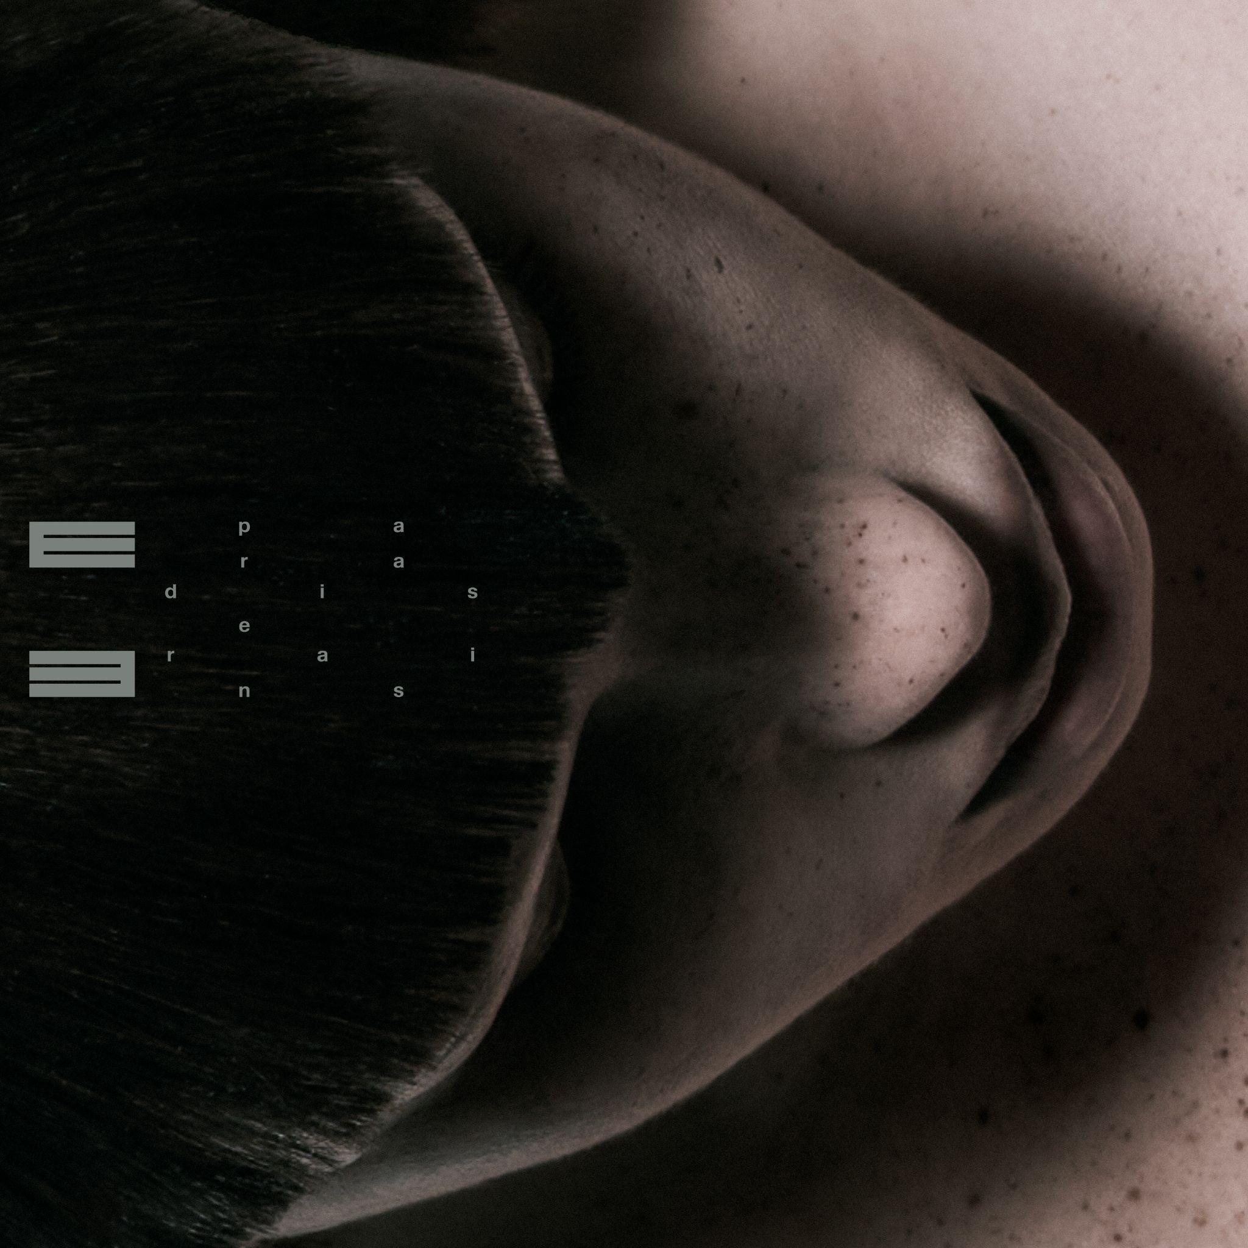
“Paradise Rains” single artwork

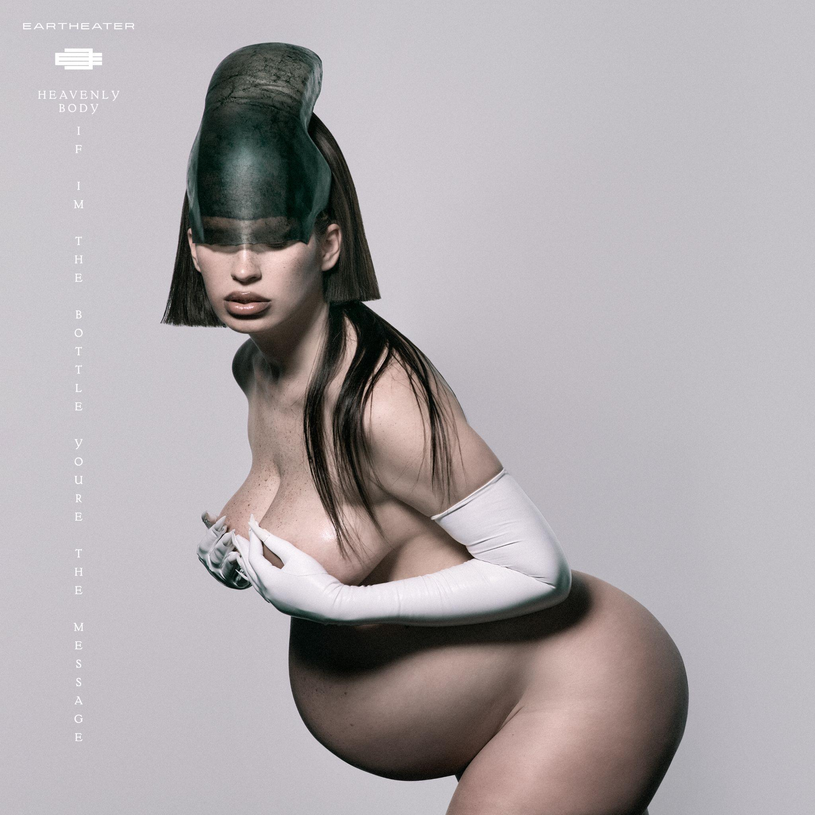
Heavenly Body: If I’m The Bottle You’re The Message album artwork

Eartheater
Heavenly Body: If I’m The Bottle You’re The Message
July 14th, 2026

1. Eyes of a Dove
2. Paradise Rains
3. Practical Amnesia
4. Crown Jewel
5. Wasp in the Fig
6. Glowing Guts
7. Hers Before Hers
8. Don’t Look Back
9. Favorite
10. Fast Asleep (featuring Oklou)
11. Nova

﻿(Download hi-res assets HERE)

Connect with Eartheater
Instagram | X (Twitter) | Website

For all Eartheater inquiries, please contact Bradley Bledsoe or Alicia Cote at Orienteer:
bradley@orienteer.us | alicia@orienteer.us

