EARTHEATER SHARES NEW MUSIC VIDEO
WATCH “WASP IN THE FIG” NOW

HEAVENLY BODY: IF I’M THE BOTTLE YOU’RE THE MESSAGE OUT EVERYWHERE NOW
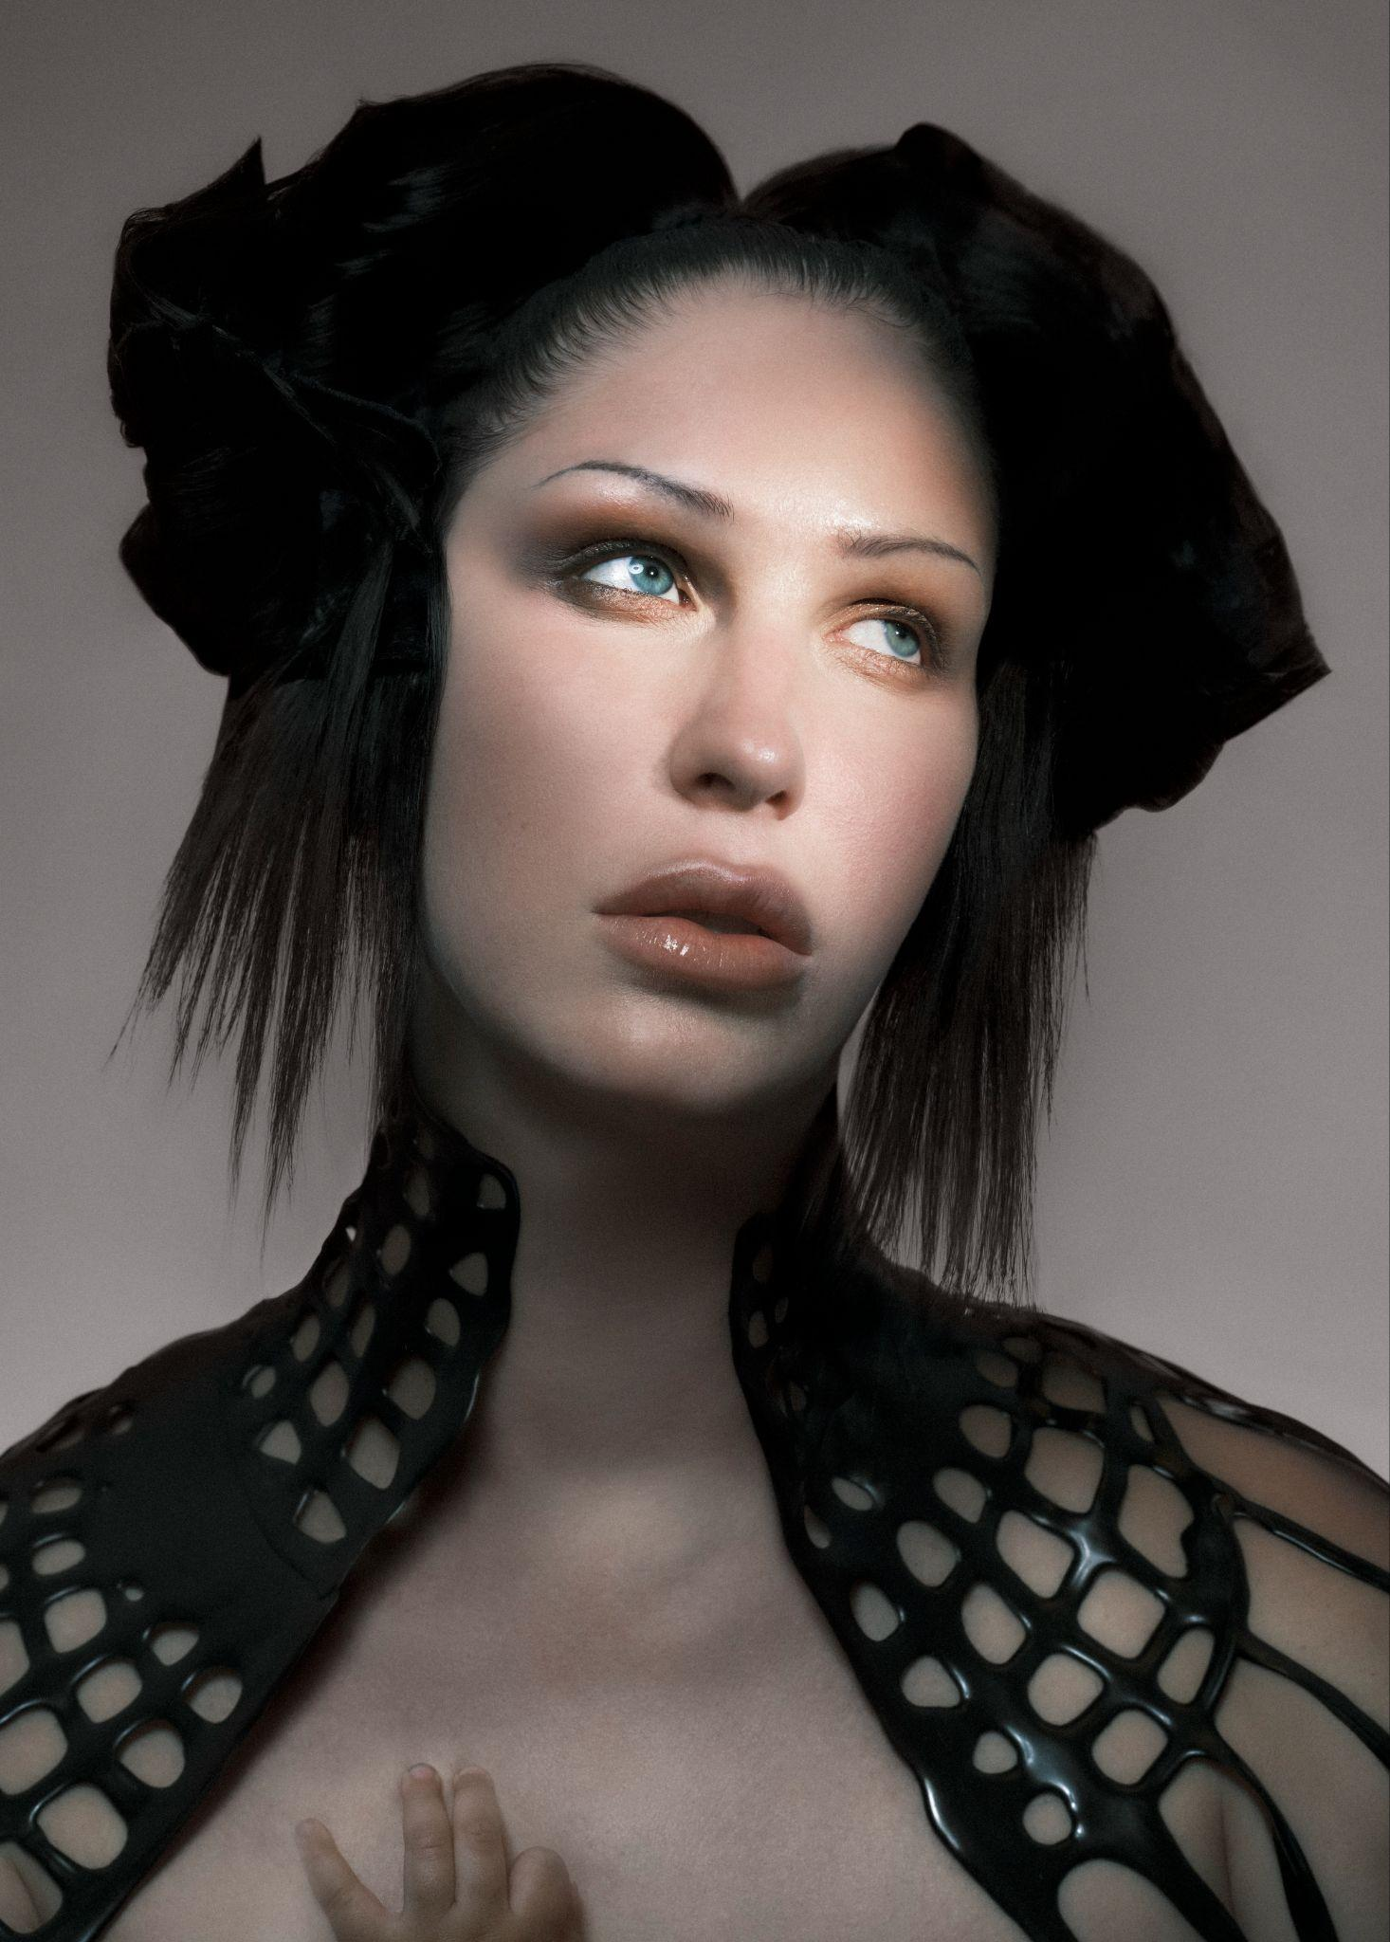
Eartheater by Vidar Logi

“Wasp in the Fig”
WATCH: LINK
Heavenly Body: If I’m The Bottle You’re The Message
LISTEN: https://chemicalx.ffm.to/HeavenlyBody
VINYL: https://chemicalx.ffm.to/heavenlybodyvinyl

What the press is saying about Eartheater:

“soaring through time and space with a boundless appetite for creation”
Paste Magazine

“remarkable emotional weight”
The Creative Independent

“capturing the chaos and ecstasy of one of the most transformative experiences the human body can endure”
Pitchfork

(September 9, 2026) - Off the back of sold out headline shows in North America and Europe, experimental composer, singer, producer and multi-instrumentalist Eartheater, the alias of artist Alexandra Drewchin, shares the music video for “Wasp in the Fig.” Directed by Andrew Thomas Huang, the otherworldly visuals see Eartheater traversing the earth and skies riding a horse before melding with the beast to become a centaur herself. The opening and closing scenes of the video were filmed flying over Drewchin’s country property.

“Wasp in the Fig” appears on her recently released album Heavenly Body: If I’m The Bottle You’re The Message, which has been praised by Resident Advisor, Pitchfork, The FADER, Paste, The Quietus, and more. Heavenly Body: If I’m The Bottle Your The Message was fully produced by Eartheater and David Sitek (Yeah Yeah Yeahs, TV on the Radio, Jane’s Addiction), outside of the closing track “Nova,” which was co-produced with Nosaj Thing and Michael Andrews (Donnie Darko), and includes a feature from fellow new mother and lauded artist, Oklou.

Eartheater recently wrapped a run of headline shows in New York City and Los Angeles, where she sold out iconic venues Bowery Ballroom and Masonic Lodge two and three times over, respectively, before bringing the ascending live experience to Europe, where she performed to sold-out crowds in Paris, London, Zurich and Berlin.

Heavenly Body: If I’m the Bottle You’re The Message, is as personal as it is universally expansive, as everyday diaristic as it is mythopoetic. Exploring the pregnant body as a vessel for something greater than itself, it offers an intimate look at what it means to carry another human, how that transforms your body and life. It’s a gorgeous, complex record, one of birth plans and playlists, peeing in cups at doctor visits, and pregnancy sex. While it’s the singular experience of one woman, it also reflects feelings other people have experienced in other ways, without having to be a parent, which adds to the collection’s power.

Sonically, Heavenly Body’s a mix of dance lullabies, exhilarating post-wave bangers, prismatic electronic anthems, and stadium-stretching art-pop. Drewchin’s in the zone here, and these songs, finely detailed and deep, feel effortless. She started making Heavenly Body a little over three months after her now 10-month-old daughter, Nova, was born. Spending just a few months on a major work is remarkable. “It is very much born from the throws and blisses of becoming a mother. Some music can wait to come out and it will make sense whenever it does. This music had to come out immediately.” When you move quickly, you have less time to second-guess yourself and the 11 resulting tracks are some of Eartheater’s catchiest and most immediate. You can feel that energy in each word and in each note.

Eartheater practices her own strain of poetic alchemy. Shapeshifting between electronic experimentation and acoustic texture, Eartheater has long delved into themes of erosion and lithification, along with the infinite possibilities of metamorphosis. In October 2025, she celebrated the 10-year anniversary of her first two albums, Metalepsis and RIP Chrysalis, classics in experimental electronic music. She’s collaborated with a variety of artists, including FKA twigs, where she contributed the top-line melody, guitar playing, and production to the lead single for twigs’ Grammy-winning album EUSEXUA, modern music chamber ensemble Alarm Will Sound, Irish-Chilean electronic producer Sega Bodega, and British singer, DJ, and rapper Shygirl. Comfortable on large stages, in punk houses, and in museums, she also understands the fashion runway: Chanel has featured her music three times in their shows, as well as Dior, Proenza Schouler, and Mugler.
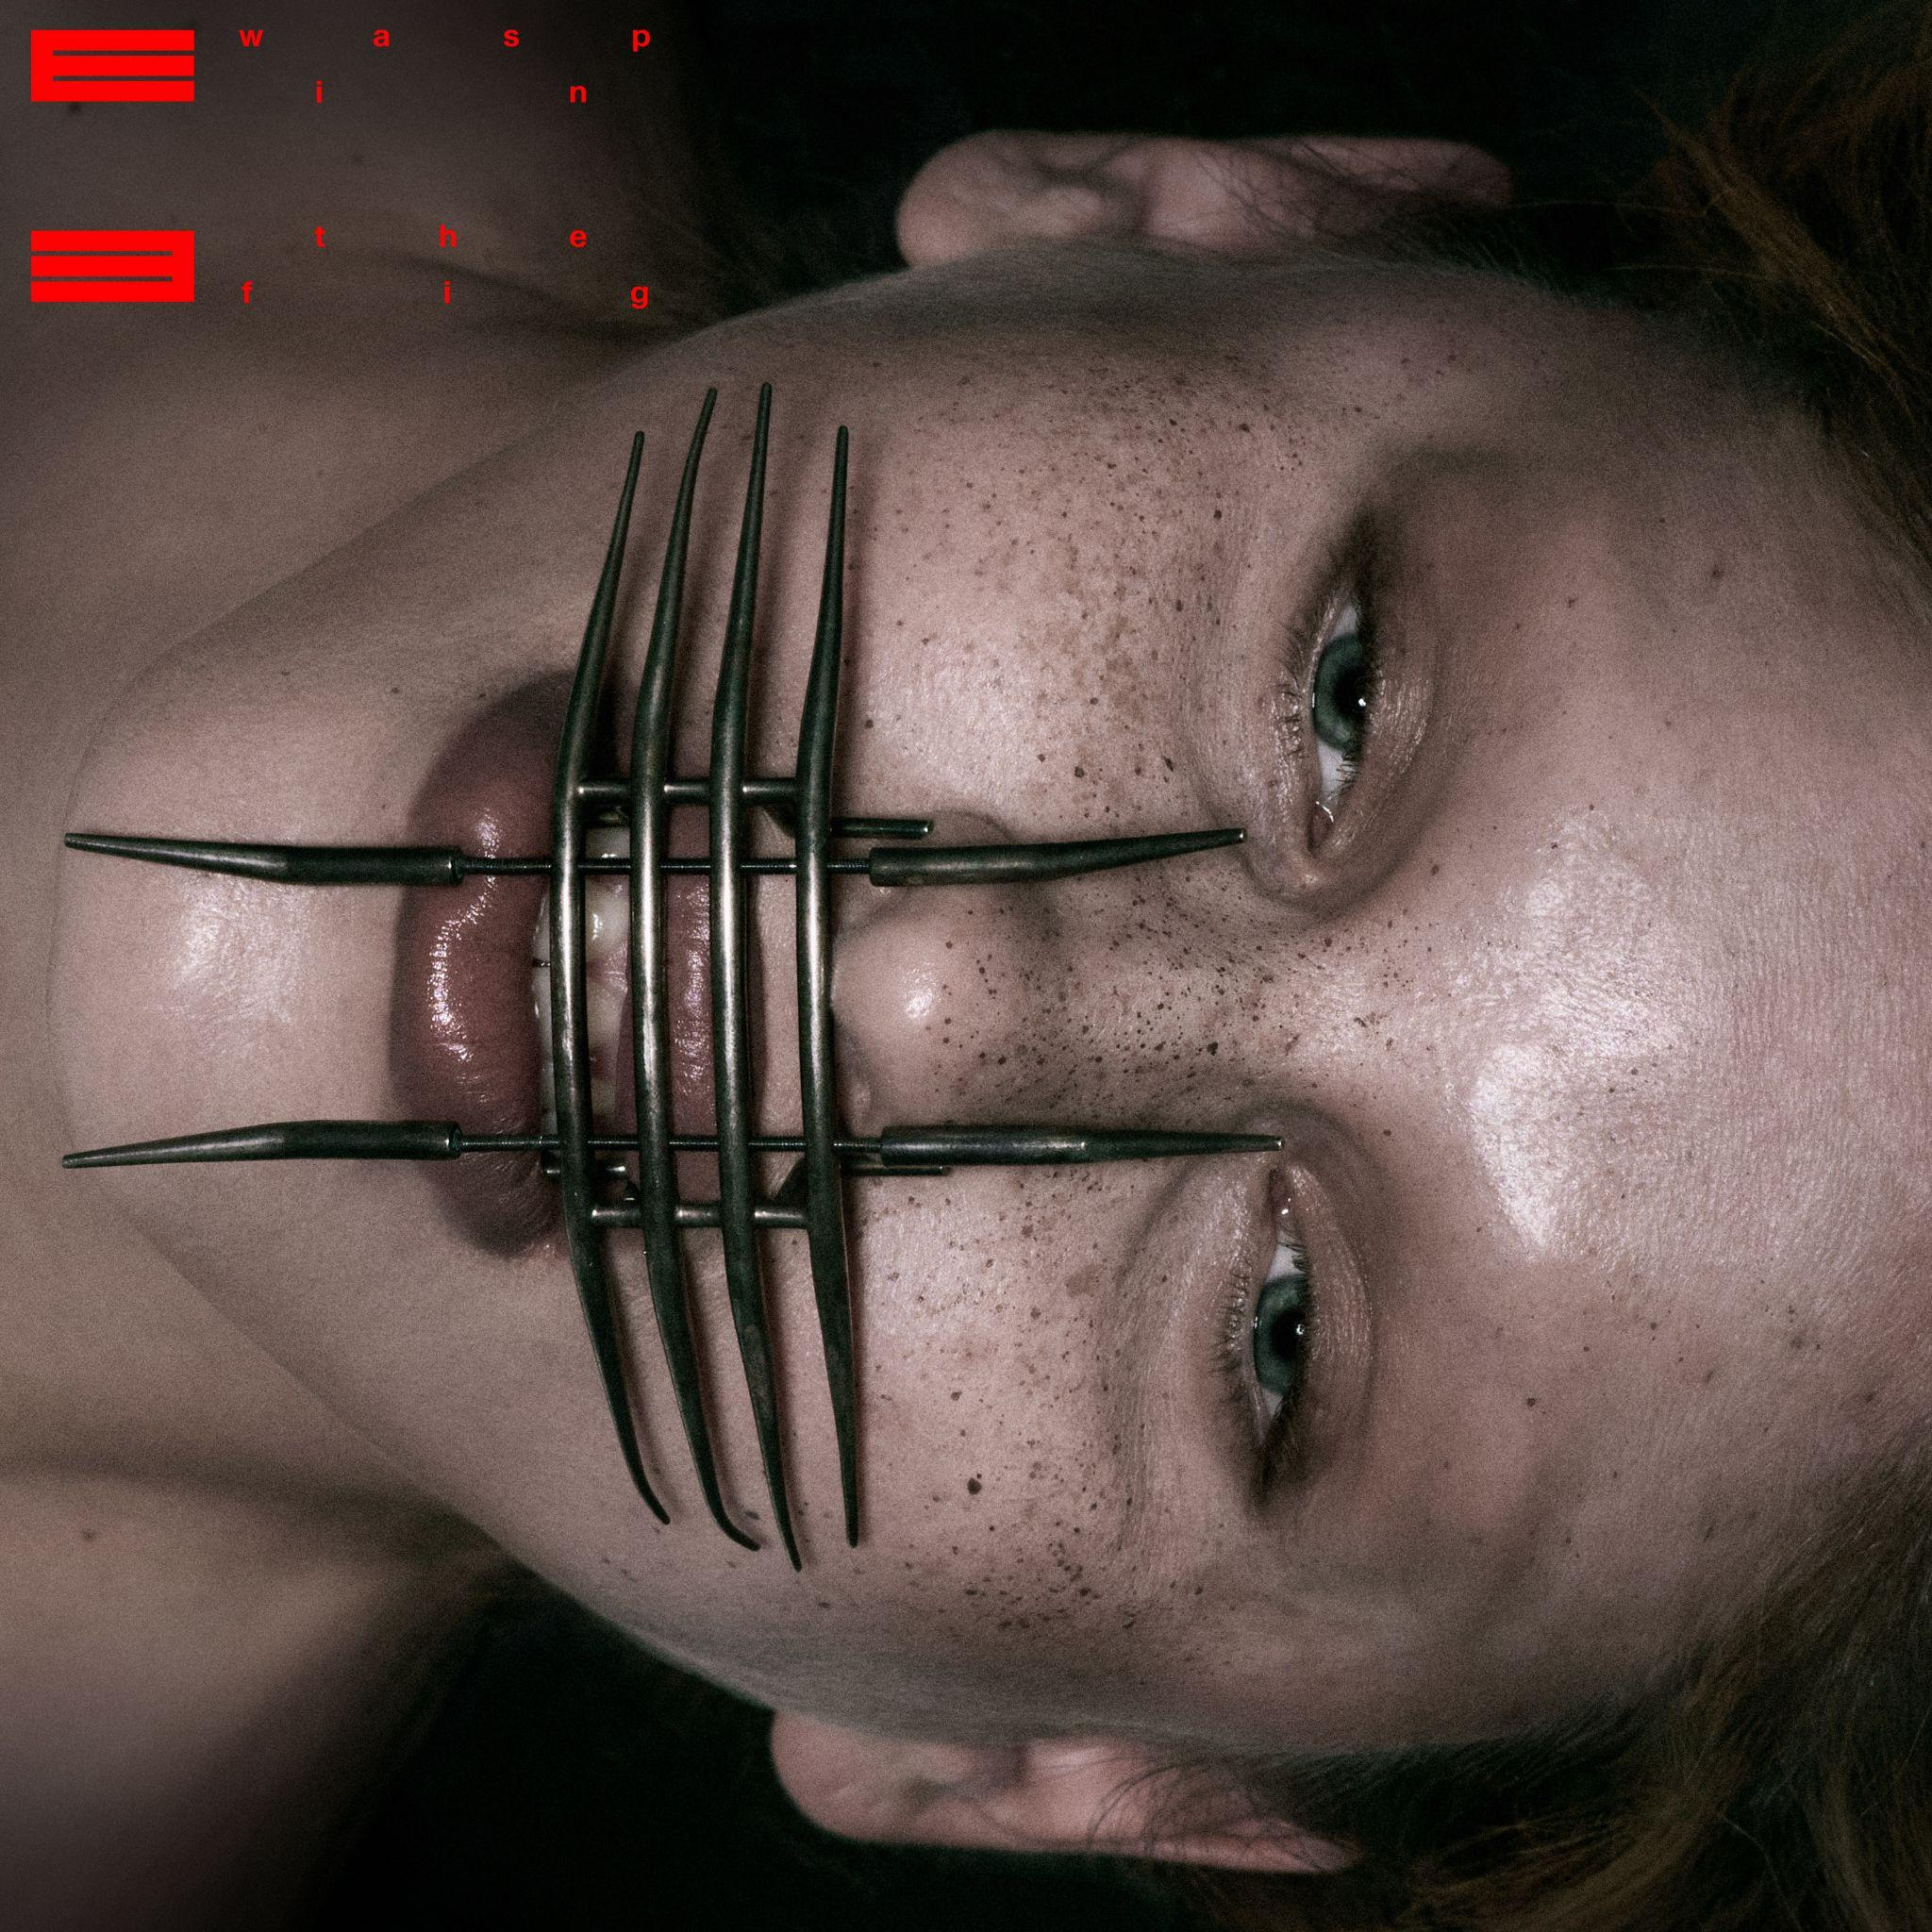
“Wasp in the Fig” single artwork

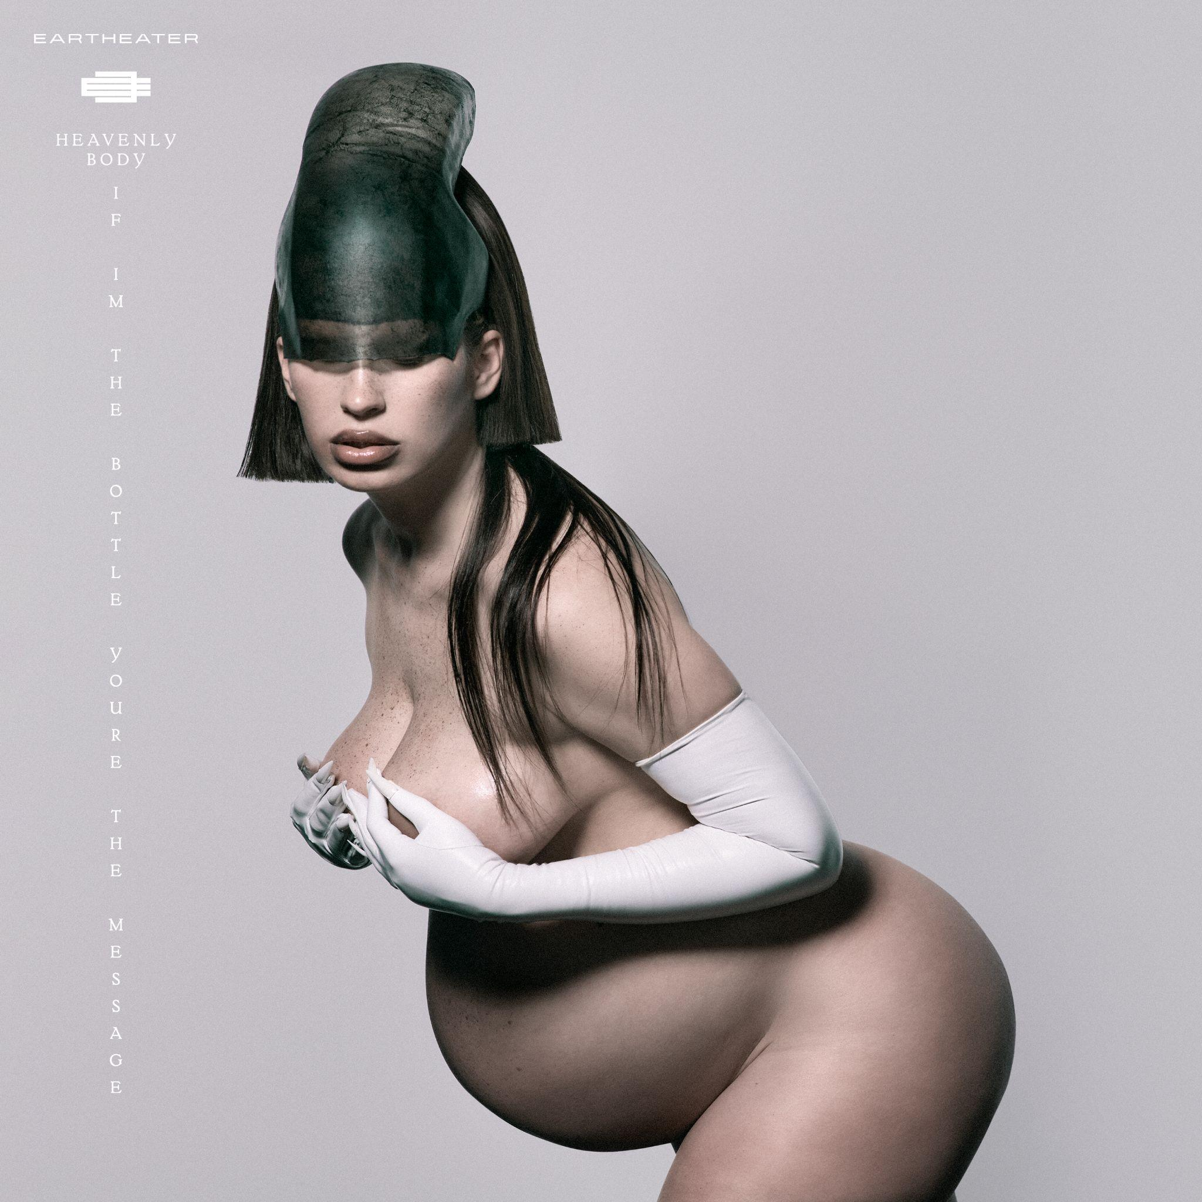
Heavenly Body: If I’m The Bottle You’re The Message album artwork

Eartheater
Heavenly Body: If I’m The Bottle You’re The Message
July 14th, 2026

1. Malka Moma
2. Paradise Rains
3. Practical Amnesia
4. Crown Jewel
5. Wasp in the Fig
6. Glowing Guts
7. Hers Before Hers
8. Don’t Look Back
9. Favorite
10. Fast Asleep (featuring Oklou)
11. Nova

﻿(Download hi-res assets HERE)

Connect with Eartheater
Instagram | X (Twitter) | Website

For all Eartheater inquiries, please contact Bradley Bledsoe or Alicia Cote at Orienteer:
bradley@orienteer.us | alicia@orienteer.us

