PENNY
COMES BACK WITH HER NEW EP “PROM?”
UNVEILS HAUNTING COVER OF JEFF BUCKLEY’S
“LOVER, YOU SHOULD’VE COME OVER”

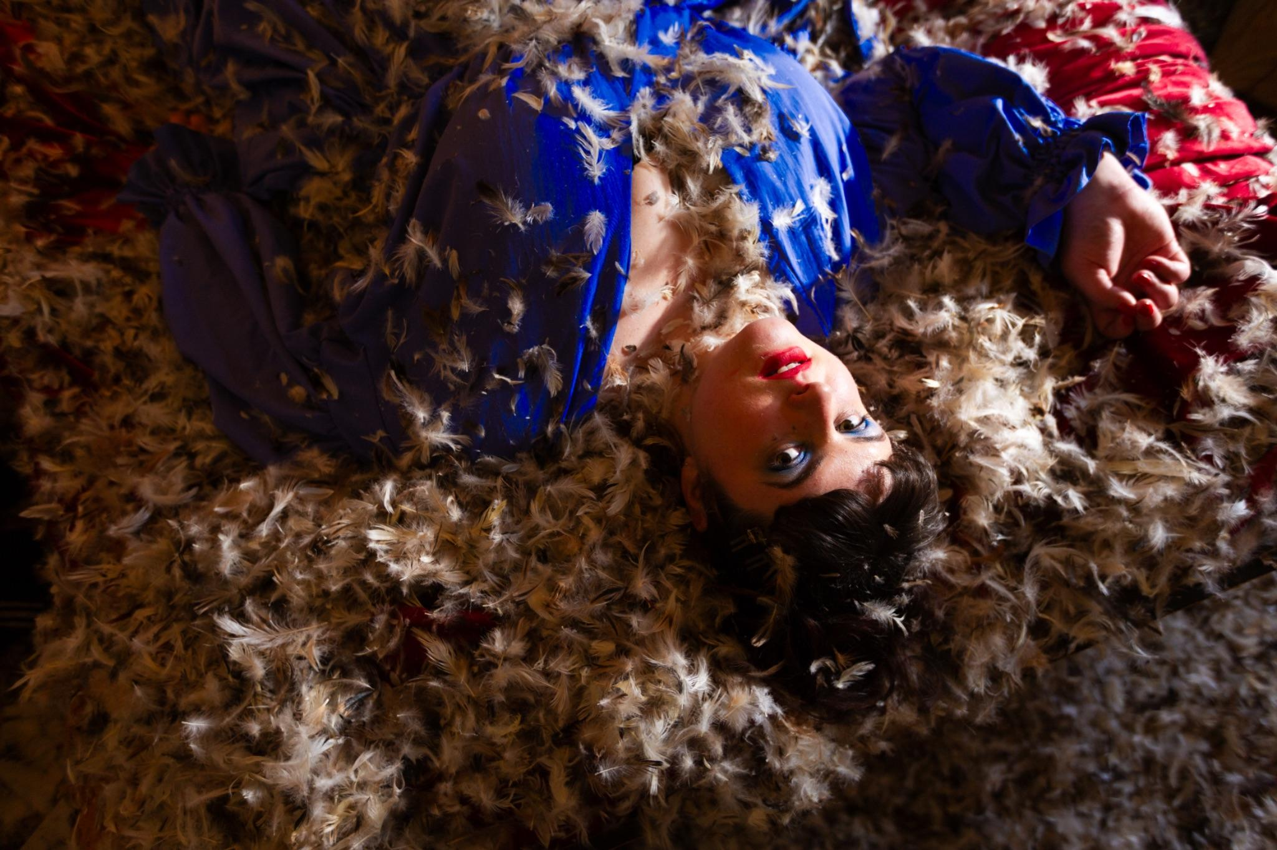

LISTEN HERE / PRESS SHOT HERE
There’s something unmistakably PENNY in the way she turns neuroses into something you can dance to. She transforms her most intimate obsessions into bittersweet pop songs, where sweetness and instability go hand in hand. With “Dirty”, the British artist leans further into that space: a tense, feverish track that captures the exact moment when desire overrides reason.
“Ever felt like you’re losing your mind??? Yeah, me too.” The tone is set. Since her debut, the British artist has explored those fragile emotional territories where desire, insecurity, humour and fantasy constantly collide.

With Prom?, her new EP out June 12, PENNY delivers her most fully realised project to date. Conceived as an adult reimagining of the teenage prom fantasy, it draws less from glossy romantic comedies than from something darker and more cinematic — somewhere between the troubled romance of Carrie and a slightly distorted vision of celebration.
“I chose the prom theme because I kinda grew up romanticising the idea of a big American teenage prom, but more like the one in Carrie (even though it’s tragic!). I feel like all the teenage angst and wonder and feeling silly and uncool but also the self-assuredness comes out at prom, and that’s what I was trying to get across through this EP, but like in an adult way?” explains PENNY.

Throughout the EP, she explores that fragile in-between space: feeling both too much and not enough, craving attention while fearing the gaze of others. Across tracks such as “Shadow Dancing”, “So Good Inside” and “Dirty”, PENNY captures moments of emotional suspension with a writing style that is both vulnerable and sharp, carried by sleek, restless pop production capable of turning spiralling thoughts into irresistible melodies.

The project is further enriched by a haunting rendition of “Lover, You Should’ve Come Over”, the timeless classic by Jeff Buckley. A choice that felt as obvious as it was intimidating. Covering Buckley might seem almost reckless — PENNY knows it, but leans into that sense of vertigo, taking on a song as beautiful as it is tragic while preserving its delicate balance between vulnerability and surrender. It is a track she discovered late, during university, and one that has stayed with her ever since.

Originally from Huddersfield, PENNY first drew attention with My Secret Powers in 2022, a debut bedroom pop EP marked by disarming sincerity. Since then, she has honed her sound, notably collaborating with The Limiñanas on “Faded”, and working alongside key figures from the British pop scene, including Michael Lovett of Metronomy on production and Ash Workman, who has worked with Christine and the Queens, Metronomy and Klaxons, but also Sam Evian on mixing. Following “Shadow Dancing” last fall, her track “So Good Inside” was featured in the Netflix series Les Lionnes, confirming a rise that feels both understated and inevitable.

With Prom?, PENNY is not trying to answer questions so much as amplify them. That is exactly where her pop hits hardest, in that unstable space where everything feels intense, absurd and vividly alive.

This summer, PENNY will continue her ascent on stage, joining the line-up of Pete the Monkey Festival on July 12, and a sold out collaborative live show at 160DL Studios in Hackney with Michael Lovett on July 14th.
.

LISTEN HERE / PRESS SHOT HERE

