JORJA SMITH ANNOUNCES THIRD ALBUM ‘WHAT ARE THE ODDS’ AND SHARES NEW SINGLE ‘ALIVE’ FEATURING WIZKID + VIDEO
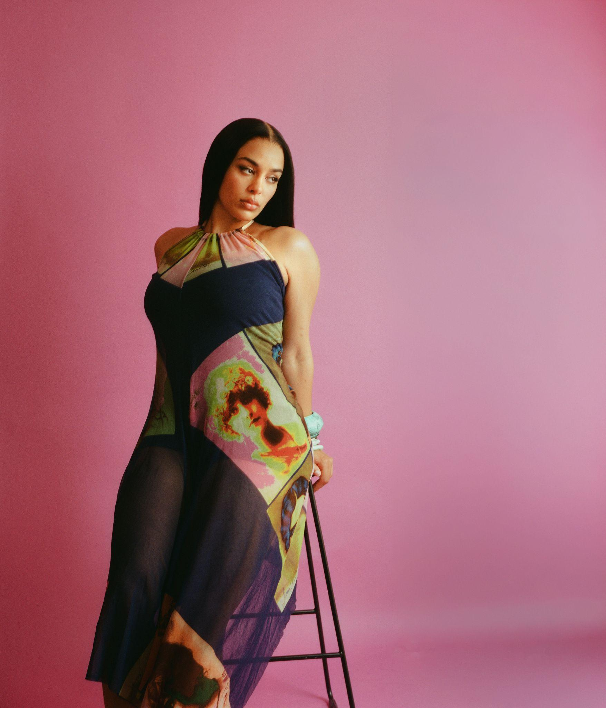
PRE-SAVE ‘WHAT ARE THE ODDS’ HERE / LISTEN TO ‘ALIVE’ FEAT. WIZKID HERE / WATCH ‘ALIVE’ VIDEO HERE / ALBUM ARTWORK HERE / ‘ALIVE’ ARTWORK HERE / LEAD IMAGE HERE / PRESS SHOTS HERE
Thursday 2nd July 2026 - Today, Jorja Smith announces her third album, ‘What Are The Odds’, set for release on Friday 21 August 2026 via FAMM, and shares new single ‘Alive’ featuring Wizkid alongside its official video.
The album will arrive on the day of Jorja’s co-headline performance at All Points East in Victoria Park alongside Tems on Friday 21 August, giving audiences the opportunity to experience the new music live on the very day it is released.
Produced by longtime collaborator P2J, ‘Alive’ is a warm, fluid and deeply atmospheric collaboration between Jorja and Wizkid. Written and recorded together in London, the track captures the exhilaration of connection and the first flush of love, pairing rich instrumentation and subtle percussion with the effortless chemistry between two of contemporary music’s most distinctive voices.
Directed by Gabriel Trautmann and shot in Paris, the accompanying video unfolds across one sweltering summer night in the city. Surrounded by a group of girlfriends, Jorja drifts effortlessly through streets, hotel rooms and late-night house parties as Paris comes alive around her. Only as the night draws to a close does she finally reunite with Wizkid, with the pair sharing the song together from a balcony overlooking the city.
Gabriel Trautmann says: “I wanted ‘Alive’ to feel like one unforgettable summer night. Paris becomes almost another character in the film - full of warmth, movement and possibility. At its heart, it’s a celebration of friendship, connection and the feeling of being completely present in a moment you never want to end.”
Featuring sole production from P2J and collaborations with Wizkid and Grime icon Devlin, who lends a re-recorded verse from his 2010 classic ‘London City’, ‘What Are The Odds’ sees Jorja embrace a euphoric, dance-led sound shaped by UK Garage, Grime, 2-Step, UK Funky, Soulful House and Afro House. The twelve-track record is built for dancefloors, festivals, house parties and journeys home after the night ends.
The genesis of ‘What Are The Odds’ was almost accidental. After connecting with P2J on ‘Little Things’, the pair talked loosely about making a dance project. When Jorja arrived at P2J’s East London studio in September 2025, she found two years’ worth of ideas waiting. What followed became ‘What Are The Odds’, with the majority of the album taking shape across just three studio sessions.
Across ‘What Are The Odds’, Jorja explores friendship, grief, growth, self-discovery and love. ‘For Life’ reflects on loving a friend through addiction, ‘Pretend’ confronts betrayal, ‘Young Heart’ looks back at a younger version of herself with affection and honesty, while the title track examines the realities of growing up in public. Elsewhere, ‘This City’ features a re-recorded version of Devlin’s iconic ‘London City’ verse, tracing Jorja’s evolving relationship with the capital while reconnecting her with the sounds and communities that inspired the record.
The announcement comes during a significant year for Jorja, marking ten years since ‘Blue Lights’ first introduced her singular voice. Earlier this year, she celebrated the milestone, appeared on the soundtrack to Riz Ahmed’s Prime Video series ‘Bait’ with ‘Price Of It All’, and performed on the debut season of Saturday Night Live UK.
Created independently and without outside pressure, ‘What Are The Odds’ finds Jorja at her most confident, open and creatively energised. It is the sound of an artist reconnecting with the joy of making music and trusting her instincts without compromise.
‘WHAT ARE THE ODDS’ TRACKLIST
- ‘For Life’
- ‘What Are The Odds’
- ‘What’s Done Is Done’
- ‘This City’ (feat. Devlin)
- ‘Pretend’
- ‘The Way It Was’
- ‘I Lied, You Lied’
- ‘Dancing’
- ‘Alive’ (feat. Wizkid)
- ‘Young Heart’
- ‘Make It Your Home’
- ‘When It Gets Like That’
‘Alive’ featuring Wizkid is available everywhere now. ‘What Are The Odds’ will be released on Friday 21 August 2026.
PRE-SAVE ‘WHAT ARE THE ODDS’ HERE / LISTEN TO ‘ALIVE’ FEAT. WIZKID HERE / WATCH ‘ALIVE’ VIDEO HERE / ALBUM ARTWORK HERE / ‘ALIVE’ ARTWORK HERE / LEAD IMAGE HERE / PRESS SHOTS HERE
FOLLOW JORJA SMITH ONLINE:
INSTAGRAM / FACEBOOK / TWITTER
For all publicity enquiries, please email Rachel Campbell rachel@wired-pr.co.uk
