MAJOR LAZER DEBUTS DAVID GUETTA REMIX OF “ROTATE” WITH AMERICA FOSTER, SKILLIBENG AND BEAM
FOLLOWS REMIXES FROM PATRICK TOPPING AND NUSAR3000, ORIGINAL VERSION TRENDING WITH MORE THAN 150 MILLION VIEWS ACROSS PLATFORMS
LIVESTREAMING FROM DIPLO’S JAMAICA STUDIO POMPEY

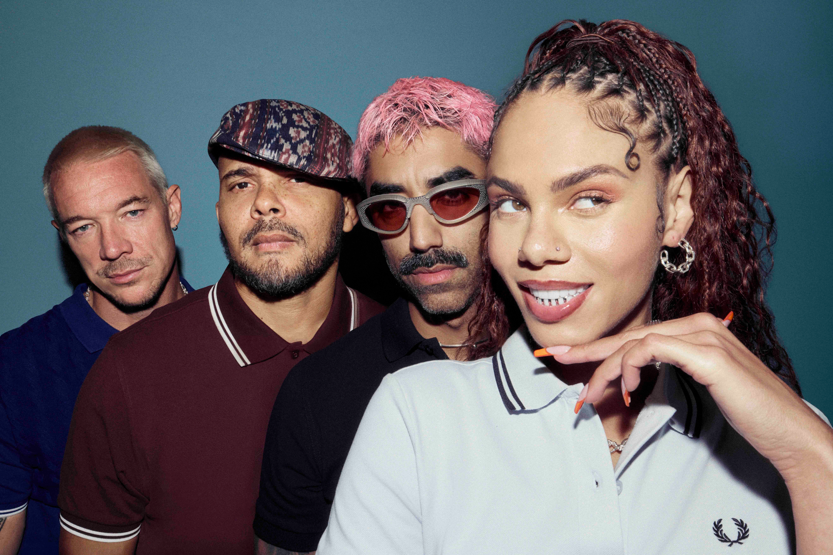Photo credit: Kenneth Capello
September 18, 2026—Pop revolutionaries Major Lazer debut the David Guetta remix “RoTATe wiTh aMeRiCa FOsTeR, sKiLLiBeNg aNd bEAM” today, following remixes from Patrick Topping and nusar3000 unveiled over the past several weeks. Listen here.
A long-awaited fan favorite, “RoTATe” is currently trending. More than 40,000 organically created dance videos from around the globe have been seen more than 150 million times across platforms. The explosive, frenetic party track is anchored by Lazer First Lady America Foster and features Jamaican superstars and frequent Lazer collaborators BEAM and Skillibeng, whose hits with Nicki Minaj, Wizkid and Shenseea (on the massive 2025 global smash “Shake It To The Max”) have taken the world by storm.
The group spent this week livestreaming from Diplo’s legendary Jamaica studio Pompey and other locations around the island, including a set at the iconic Blue Lagoon. The stream—twelve hours across two days—saw Diplo, America Foster, Walshy Fire and Ape Drums playing unreleased music, competing in challenges and completing sidequests, with special guests including Busy Signal, Witty, and GIDEON (@sidequestz). This weekend, Major Lazer heads to Las Vegas for an appearance at the iHeartRadio Music Festival.
“RoTATe” arrived alongside a bombastic dance video starring the Lazer Gyals—the group’s legendary live dancers—and choreographed by longtime collaborators Sara Bivens, an original Lazer Gyal, and Calvit Hodge, whose recent credits include work with Peso Pluma, Camila Cabello and more. Listen here and watch here.
The track features a sample of Puppah Nas-T and Denise Belfon’s legendary record “Work,” which has been remixed and sampled by everyone from house icons Masters at Work and Jersey Club star DJ Sliink to Drake and Megan Thee Stallion.
Amid their first extensive touring in seven years, Lazer has played to massive crowds at festivals across North America and Europe this summer including Coachella, Lollapalooza, Governors Ball and Bonnaroo. The group debuted a new show for their latest chapter, with creative direction from Mike Carson and choreography by Bivens and Hodge. The enormous production features immersive visuals, eight dancers, intricate stage sets and many more surprises.
Major Lazer opened this new era with their much-lauded mixtape GYALGEBRA at the end of 2025, which served as an introduction of the group’s newest member, London multi-hyphenate America Foster. In the months since, they’ve continued to release massive tracks including “pAPi” featuring Dominican superstar Tokischa,
The Diplo-founded ensemble is one of the most successful groups in pop, featuring longtime members Walshy Fire and Ape Drums alongside new addition Foster. Major Lazer has delivered era-defining hits including “Lean On”—one of the most successful songs ever, 4x Platinum-certified “Cold Water” and 2x Platinum-certified “Light It Up,” and collaborated with an array of global superstars like Beyoncé, J Balvin, WizKid, El Alfa, Burna Boy, Travis Scott and Ariana Grande.
MAJOR LAZER LIVE
September 19—iHeartRadio Music Festival—Las Vegas, NV
October 9—Singapore Grand Prix—Singapore*
*Major Lazer Soundsystem
majorlazer.com

