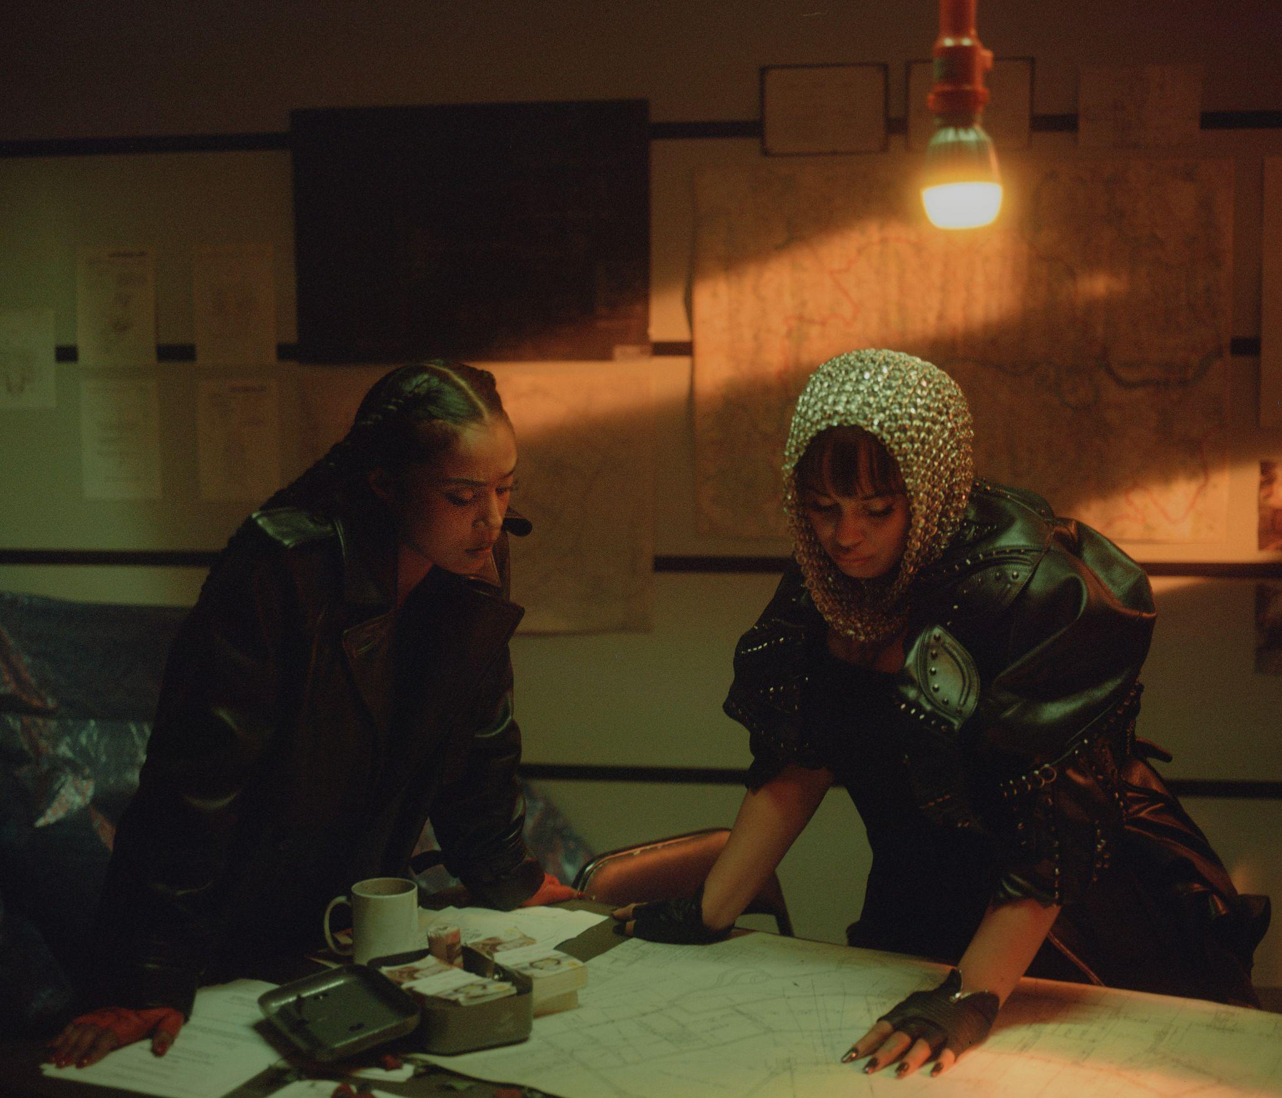

JORJA SMITH UNVEILS VIDEO FOR ‘FEELINGS’ FEAT. J HUS, STARRING JASMINE JOBSON
WATCH HERE / LISTEN HERE / PRESS IMAGES HERE

JORJA’S CRITICALLY ACCLAIMED SECOND ALBUM ‘FALLING OR FLYING’ IS OUT NOW

SUNDAY TIMES CULTURE - ★★★★★
DIY MAGAZINE - ★★★★
EVENING STANDARD - ★★★★
DAILY MIRROR - ★★★★
ROLLING STONE UK - ★★★★
NME - ★★★★
FINANCIAL TIMES - ★★★★

October 16th 2023 - British singer Jorja Smith has unveiled the accompanying video for ‘Feelings’; a track taken from her second album ‘falling or flying’ of which she released to critical acclaim last month.

Directed by British Director Femi Ladi, the video mirrors the old-age story of ‘Bonnie & Clyde’ - but this time with a twist. Starring Top Boy actress Jasmine Jobson, the storyline showcases multiple different characters for both stars, offering up a cinematic and incredibly thrilling plot of criminals on the run.

The accompanying video arrives hot off the heels of the release of Jorja’s second album, ‘falling or Flying’; a sonically vast record – sometimes sleek and shiny R&B, sometimes vibey and heated UK funky, elsewhere intense and raw alternative – is a record which finds an artist stepping into a new chapter.

Jorja’s acknowledging the ever-whirring cogs of her brain but also moving through it, growing, respecting herself above everything else. It’s why the defiant lead single ‘Try Me’ – an astute, self-dissecting take on being viewed by the public gaze over bold, intricate beats – is also the opening track of the album. She explains: “It’s kind of ‘BAM!’, you know? It whacks you right in the face, it sounds like an entrance.” She credits the record’s slick and assured musicality to production duo DAMEDAME*: “I feel like making the album brought me back home,” she smiles, warmly, “Where you’re from is where you get your powers, and that’s why I’m so grateful I could make this with DAMEDAME* – they still have their roots in the ground from back home. And we had so much fun making this.”

She says the first half of the album is the flying, the feeling herself, and midway through there’s a switch from the confidence to the insecurity and self-doubt of falling. We go from 2023’s summer anthem ‘Little Things’ to a glorious J Hus feature ‘Feelings’, to the title track, all of which find Jorja navigating friendships, her relationship with herself, and trying to move to men at parties – and often finding them coming up short. Then there’s ‘Go Go Go’, a propulsive indie-adjacent track that nods to Jorja’s teen love of groups like Jaws, The Kooks, Bombay Bicycle Club. “I’m in my little alt bag, but I’ve always kind of been in it,” she grins, “People might be like, ‘I didn’t expect this’, but I’m like: ‘well, I would.’” The track also marks the shift to the ‘falling’ half of the album, switching to a sound that’s more intense but also perhaps more introspective. Beyond that point, there are beautiful songs like ‘Try and Fit In’, which utilises the choir of 11 to 18 year old girls she’s started since moving back to Walsall, recognising the dearth in spaces for young people to congregate and create with the closure of youth centres.

There’s the touching letter to her younger self in the form of ‘Greatest Gift’, featuring Lila Iké, which is an acknowledgement of her pride in herself, but also the desire to get back to her inner-child. There are tracks about being made to doubt herself in the face of a man gaslighting her, reflecting on whether past “loves” were ever really love at all; songs which explore the realities of the limelight versus life for those who are behind-the-scenes, airing her upset or gratitude for people who she’s not sure will ever realise the lyrics are about them. Though, with that said, more often than not she recognises the tracks are more self-reflective than anything else: “So much of the time I think I’ve written a song about someone, and then realise I’m actually talking about myself,” she muses, “So sometimes these songs are just me being there for myself.”

Of the many British voices in music today, Jorja is among the most commanding, writing at a pitch of intensity and urgency that few can match. Over the past five and half years, since the release of her critically acclaimed debut album ‘Lost & Found’, she has been celebrated unanimously across the world for her evocative song-writing, powerful delivery, pure emotion and unbridled talent as a young woman navigating her way through life. It was in 2021 that Jorja’s hiatus from music was broken - enter ‘Be Right Back’, the holding space between the sensation that was ‘Lost & Found’, and her next project. ‘Be Right Back’ was born from playing, jamming, freestyling, and sounding out what Jorja had been on the edge of expressing all her life. It was a project entirely for her fans. “Be Right Back did exactly what I wanted it to do. It was a little waiting room so people knew I was coming back.”

And come back she did - entering a chapter of her return to music that’s certain to draw in and intoxicate Jorja’s fans and new listeners alike. And what has changed for her, in the five years since ‘Lost & Found’ dominated the charts and the soundscape, “I like this world that I've just come into. And I’m still figuring things out. Always figuring things out.” Jorja says. “This is the first time I’m putting stuff out there that I can connect with right now.” Over the last few years, it’s been a reflective and transformative transition into her mid twenties for her. She’s been able to step into herself and evolve as a songwriter and a woman despite an ever-changing musical landscape.

On ‘falling or flying’, Jorja Smith is reminding herself (and us), that whether things are up or down, she’s very much in control. In fact, as she grows and holds herself, she’s fully thriving.

‘falling or flying’ - Tracklist:

- Try Me
- She Feels
- Little Things
- Flights Skit
- Feelings Feat. J Hus
- Falling or flying
- GO GO GO
- Try and fit in
- Greatest Gift Feat. Lila Iké
- Broken is the man
- Make sense
- Too many times
- Lately
- BT69 JJY
- Backwards
- What if my heart beats faster?

WATCH ‘FEELINGS’ VIDEO HERE

STREAM/PURCHASE ‘FALLING OR FLYING’ HERE // ARTWORK HERE // PRESS SHOTS HERE

For publicity enquiries, please contact Rachel Campbell at Wired PR - rachel@wired-pr.co.uk

FOLLOW JORJA SMITH ONLINE:
INSTAGRAM
FACEBOOK
TWITTER

