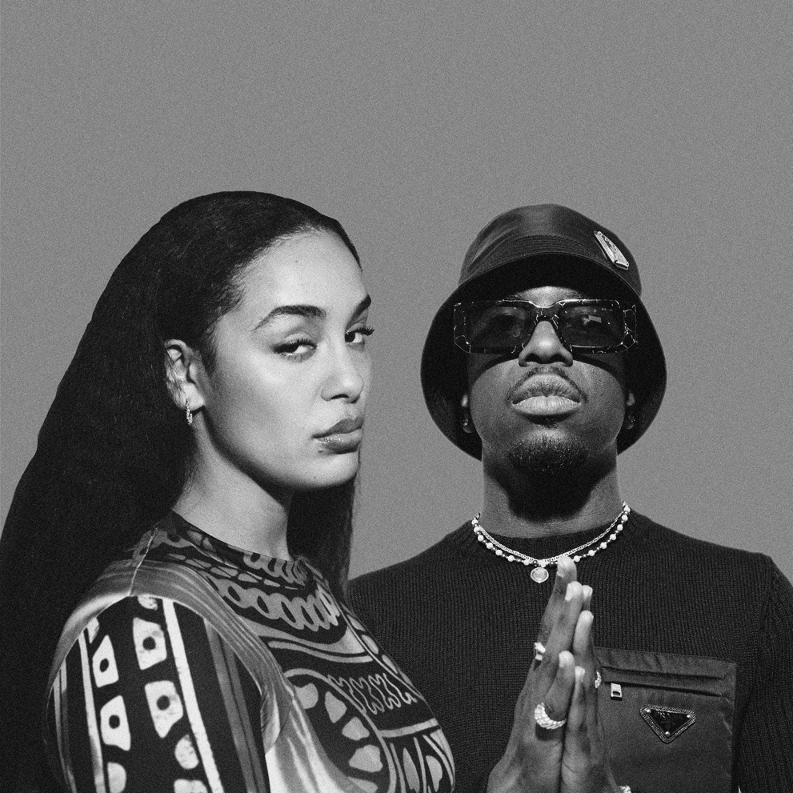
(composite)

GO GO GO (feat. Josman)
OUT March 22nd
Link: https://jorjasmith.lnk.to/GOGOGOFeatJosman

From the moment she burst onto the R&B scene in 2017 to the present day, Jorja Smith has established herself as one of the most important voices of her generation. And the reason she has succeeded so strongly is also because of her ability to collaborate with all musical genres.

There has of course been afropop with Burna Boy for the hit 'Be Honest' (over 300 million streams), house music with Drake and Black Coffee ('Get It Together') reggaeton with Kali Uchis ('Tyrant') and of course rap. Since her debut album Lost & Found (now certified platinum in France), the English singer has collaborated several times with figures from the genre, particularly in France. Like her track "Blue Lights" with Dosseh (certified platinum) or "Come Over" with Oboy, which now has nearly 60 million listens on streaming platforms.

On "GO, GO, GO", taken from her second album falling or flying, released in autumn 2023, Josman, a major figure in French rap in recent years, has teamed up with the singer for the French version. The pop-rock-tinged track is a two-voice evocation of the toxic relationships from which we must inevitably escape. First Josman lays down his bitter spleen on the guitars of producers DAMEDAME*, then Jorja Smith takes over and tells her own story.

With this new collaboration, the singer continues to maintain her strong link with French rap on a track that is both personal and universal. It is accompanied by a colourful, animated video by international illustrator Aurélia Durand (author of the New York Times bestseller "This Book is Anti-Racist").

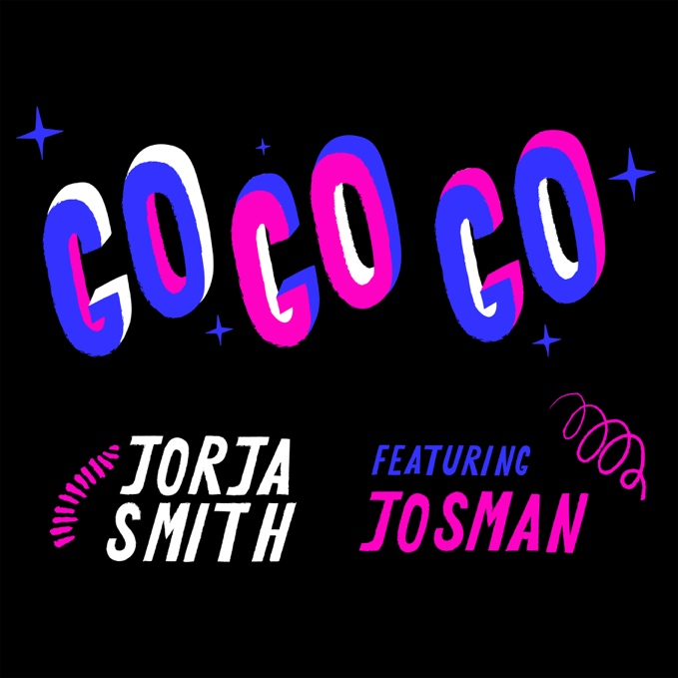
(single artwork)

