JESHI

‘BAD TASTE’
DEBUT EP OUT NOW ON BECAUSE MUSIC

LISTEN HERE

"Sit-up-and-listen sensational...this guy is something else" Sunday Times Breaking Act
"Sharing all too familiar stories...Jeshi is putting everything into his music" i-D
"Sits somewhere between the apocalyptic grit of slowthai and brooding ambivalence of King Krule...Jeshi defies categorization" Notion
"Intensively creative, remarkably broad" Clash
"Dark and stormy UK rap" The Fader

‘Bad Taste’ is the debut EP from fast-rising UK rapper Jeshi. It’s out today on Because Music and you can stream it HERE.

An ambitious, multi-dimensional young talent, Jeshi grew up in Walthamstow in the early 2000s, with a childhood soundtracked by the likes of The Neptunes, Eminem, and Erykah Badu (alongside later game-changing influences like Toro Y Moi, and Lana Del Rey's 'Video Games' visual). He began writing lyrics and rapping amidst his mates at the start of secondary school, with a love of the DIY-spirit first manifesting in a home studio that literally consisted of a Nintendo Wii USB microphone from a karaoke game plugged straight into a desktop PC.

Across a couple of formative projects thus far - notably 2017's 7-track EP, 'The Worlds Spinning Too Fast' - Jeshi has emerged an enigmatic artist of disarming candour. He has also already collaborated with Mura Masa and toured alongside slowthai and Yellow Days - not to mention appearing on COLORs, Boiler Room and NTS.
All this has set the stage perfectly for ‘Bad Taste’ – his first official EP release since signing to Because Music. Earlier this year, Jeshi dropped ‘SAME SONGS’ marking a terrific flag in the sand for the East London talent. He quickly followed it up with ‘COMING DOWN’ last week – another fiercely impressive demonstration of what can be expected from him on his debut EP. Both have been heavily supported by fans and critics alike – picking up a heap of plays on both Radio 1Xtra with Jamz Supernova and 6 Music’s Mary Anne Hobbs.

‘Bad Taste’ is an outstanding 7 track EP, that finds one of the most promising new voices in British rap effortlessly setting the bar for 2020. Including both ‘SAME SONGS’ and ‘COMING DOWN’, it also features 30,000 FEET which features girl-of-the-moment and BRIT Rising Star Award winner Celeste (the pair previously teamed up on Celeste's 'Summer').

LISTEN TO ‘BAD TASTE’ HERE
Bad Taste EP tracklisting:
SAME SONGS
CHROME BENZO
COMING DOWN
LENS
SWAN LAKE
KISS THE FLAME
30,000 FEET (ft. Celeste)

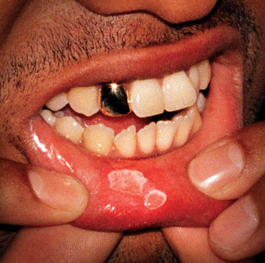

FOLLOW JESHI
INSTAGRAM | FACEBOOK | SPOTIFY

For more information please contact Bruno.lebolloch@because.tv / Joan.plana@because.tv

