Strictly embargoed until Thursday, July 6 @ 9:00 PM PST / 12:00 AM EST

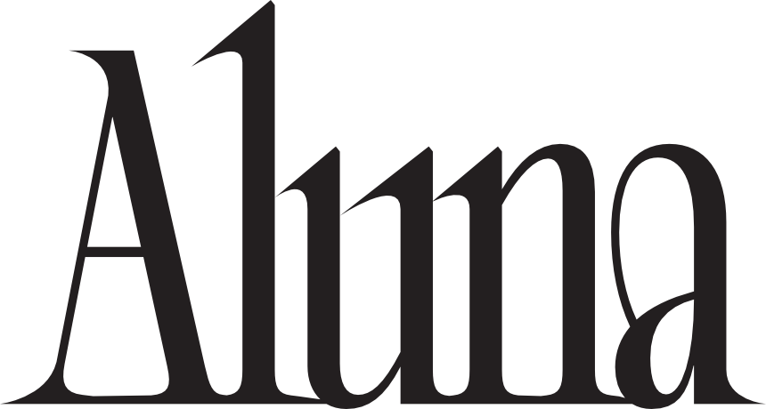

ALUNA RELEASES SOPHOMORE SOLO ALBUM, ‘MYCELiUM’ – OUT TODAY
[MAD DECENT/BECAUSE MUSIC]

NEW FOCUS SINGLE ‘RUNNING BLIND’ WITH TCHAMI & KAREEN LOMAX –
OUT NOW

FALL TOUR DATES ANNOUNCED – TICKETS ON SALE NOW

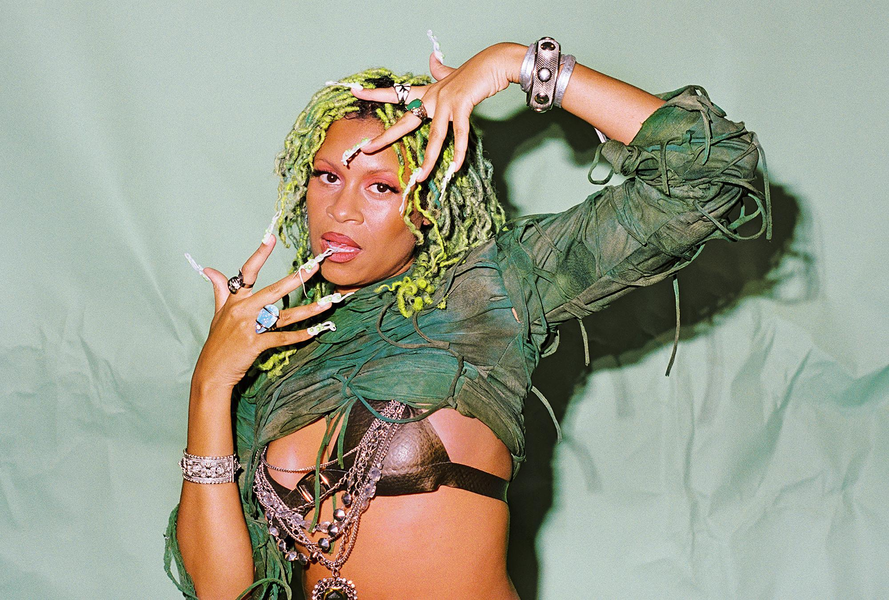
Photo Credit: Maya Fuhr

LISTEN
MYCELiUM

Tracklist:
1. Before The Bloom (Intro)
2. The Way I’m Wired
3. Underwater (with Route94)
4. Killing Me (with TSHA)
5. Supernova (with Picard Brothers & Kaleena Zanders)
6. Love and Money (Interlude)
7. Oh The Glamour (with Pabllo Vittar, MNEK & Eden Prince)
8. Running Blind (with Tchami & Kareen Lomax)
9. Mine O’ Mine (with Jayda G)
10. Sugar (with Preditah & Lauren Faith)
11. Beggin' (with Chris Lake)
12. Kiss It Better (with MK)
13. Playin Wit Ya (with Walker & Royce)
14. Future (with Kooldrink)

LISTEN
‘RUNNING BLIND’

NORTH AMERICAN TOUR & FESTIVAL DATES
07/07 – Calgary Stampede Festival – Calgary, AB^
08/05 - Bleached Festival - San Diego, CA^
08/06 - Higher Ground Festival - Seattle, WA^
08/11 - Das Energi Festival - Salt Lake City, UT^
09/01 - North Coast Festival - Chicago, IL^
09/02 – Phoenix Hotel – San Francisco, CA⇑
09/08 – The Church – Denver, CO⇑
09/09 – The Fonda – Los Angeles, CA⇑
09/10 – 916 Block Party – Sacramento, CA^
09/23 – Red Rocks Amphitheatre – Morrison, CO++
09/24 - Red Rocks Amphitheatre - Morrison, CO++
10/06 – Velvet Underground – Toronto, ON⇑
10/07 – Magic Stick – Detroit, MI⇑
10/13 – Warehouse on Watts – Philadelphia, PA⇑
10/14 – Culture – Washington, DC⇑
10/20 - III Points Festival - Miami, FL^
11/11 – Elsewhere – Brooklyn, NY⇑
⇑Headline Show
^Festival Dates
**Supporting Galantis
++Supporting Louis The Child

Aluna has released her highly anticipated sophomore album MYCELiUM, out now via Mad Decent/Because Music.

Listen to MYCELiUM HERE.

Also revealed today, is her current focus track, ‘Running Blind’ produced by Aluna alongside French producer and DJ Tchami, with vocals from Atlanta-born artist, songwriter, and producer Kareen Lomax.

Aluna reveals, “This is an unusual track on the album because Tchami actually sent me this beat and I wrote to it remotely. The irresistible sound just immediately made me think of the insatiable pull that freedom has on me. I met Kareen Lomax on the night that Beyoncé became the first Black woman to win a GRAMMY for Best Dance/Electronic Album and we celebrated together. The next morning, I knew she had to tell this story with me. In my experience, freedom is not something you win on your own, just like I wasn’t able to single handedly change the industry for Black women. When Kareen effortlessly added her poetry, the song took on a whole new level and I finally felt like it was doing the job it was meant.”

Listen to ‘Running Blind’ HERE.

While Aluna has always defied dance music orthodoxy by virtue of her own predilection for the genre, she has also made inroads for other creatives to follow her unapologetic path. It’s why she’s quietly become a boundary-breaking force, merging electronic, indie, alternative, and pop and integrating voices rarely represented in this space. Change happens by reshaping and recalibrating the ruins of yesterday into a stronger tomorrow, but rather than wait around for the system to wake up, Aluna has actively architected structures to supportive a brighter, bolder, and, always, more inclusive future in dance.

On her latest album, Aluna shares: “The Mycelium is the cell network seeped into the fabric of nature. I’m not talking about the bloom or the fruits. You need to lay the groundwork to see the fruit one day. I got burnt out from trying to work with powerful people who have lots of money and no actual genuine care for what I’m trying to do. I realized there was no foundation where I was standing, and we have to build our own foundation. It’s not going to be all bells and whistles; it’s going to be substance. So, I broke some barriers and started mentoring creative fans. I built a community of Black Ravers on Geneva and by joining groups on Instagram and social media. Now, the album is my community I’ve created.”

The multi-award-winning British (of Jamaican and Indian heritage) artist naturally began to build this ecosystem that would later become MYCELiUM, one move at a time, throughout 2022 in London, Paris, and Los Angeles. This time around, she emphasized the use of analog gear, infusing her music with organic and raw energy, and collaborating with likeminded visionaries worldwide, attracting a cohort of Black and LGBTQ+ collaborators and allies. These ranged from KOOLDRINK in South Africa, Roofeeo in Panama, Pabllo Vittar in Brazil, and Picard Brothers in France to TSHA, Chris Lake, and MNEK in London and many more. The result, MYCELiUM, a timeless celebration of 90’s era dance music and the communities and cultures that helped impact its movement and message to this day.

Speaking about the importance of the collaborators on this project, Aluna adds “I was always used to being the only Black person in the room, not only on stage, but also in all of the meetings and studio sessions. To be able to work with producers who are not only Black but LGBTQ+ was the most life-affirming stage of my career. Writing remotely also opened up the door for me to be able to collaborate with people in other countries too.”

Last month, Aluna released ‘Oh The Glamour,’ a delightfully deep groove assault to the senses, and collaboration with Brazilian GRAMMY® nominated artist Pabllo Vittar, GRAMMY® and BRIT nominated MNEK, and UK producer Eden Prince. Listen to ‘Oh The Glamour’ with Pabllo Vittar, MNEK & Eden Prince HERE

Following her packed-to-the-rafters set at Coachella’s DoLab tent, Aluna can next be seen playing a series of summer festivals, Bleached Festival in San Diego, CA (TICKETS), Higher Ground Festival in Seattle, WA (TICKETS), North Coast Festival in Chicago, IL (TICKETS) and more. She will then head out on her own headline tour this Fall, including dates in San Francisco, Denver, Los Angeles, Toronto, Detroit, Philadelphia, Washington, DC, Brooklyn, NY and more. Following two back-to-back SOLD OUT performances with Swedish electronic music collaborative Galantis last week at Brooklyn Mirage, Aluna is slated to take the stage as a special guest of American electronic duo Louis The Child for two nights at the iconic Red Rocks Amphitheater in Morrison, CO, September 23 and 24. For a list of all tour dates and details, please visit https://www.alunageorge.com/.

New focus track, ‘Running Blind’ with Tchami and Kareen Lomax is out now.

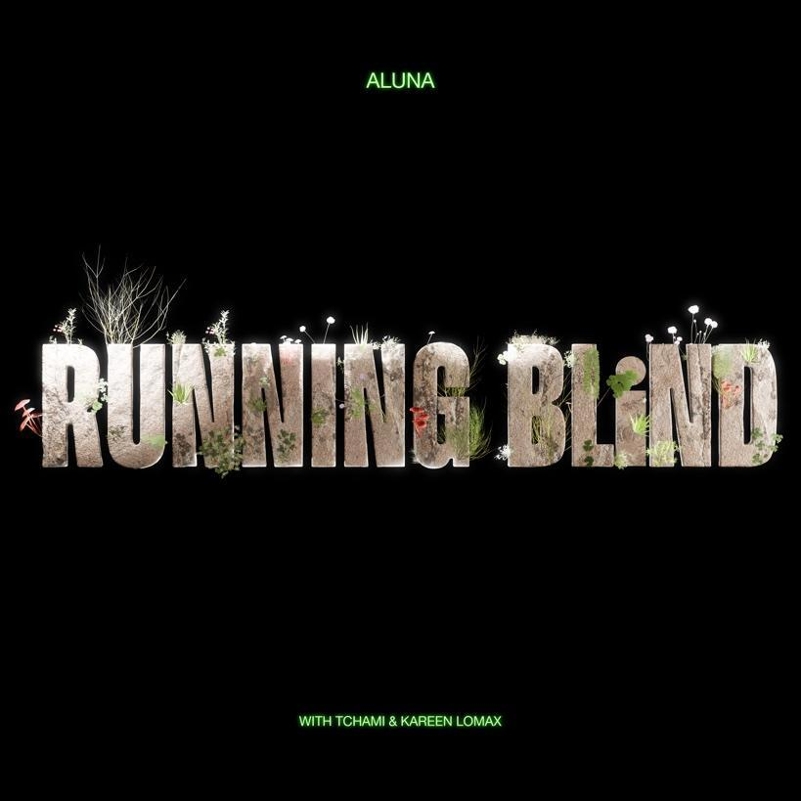

MYCELiUM is available everywhere now.

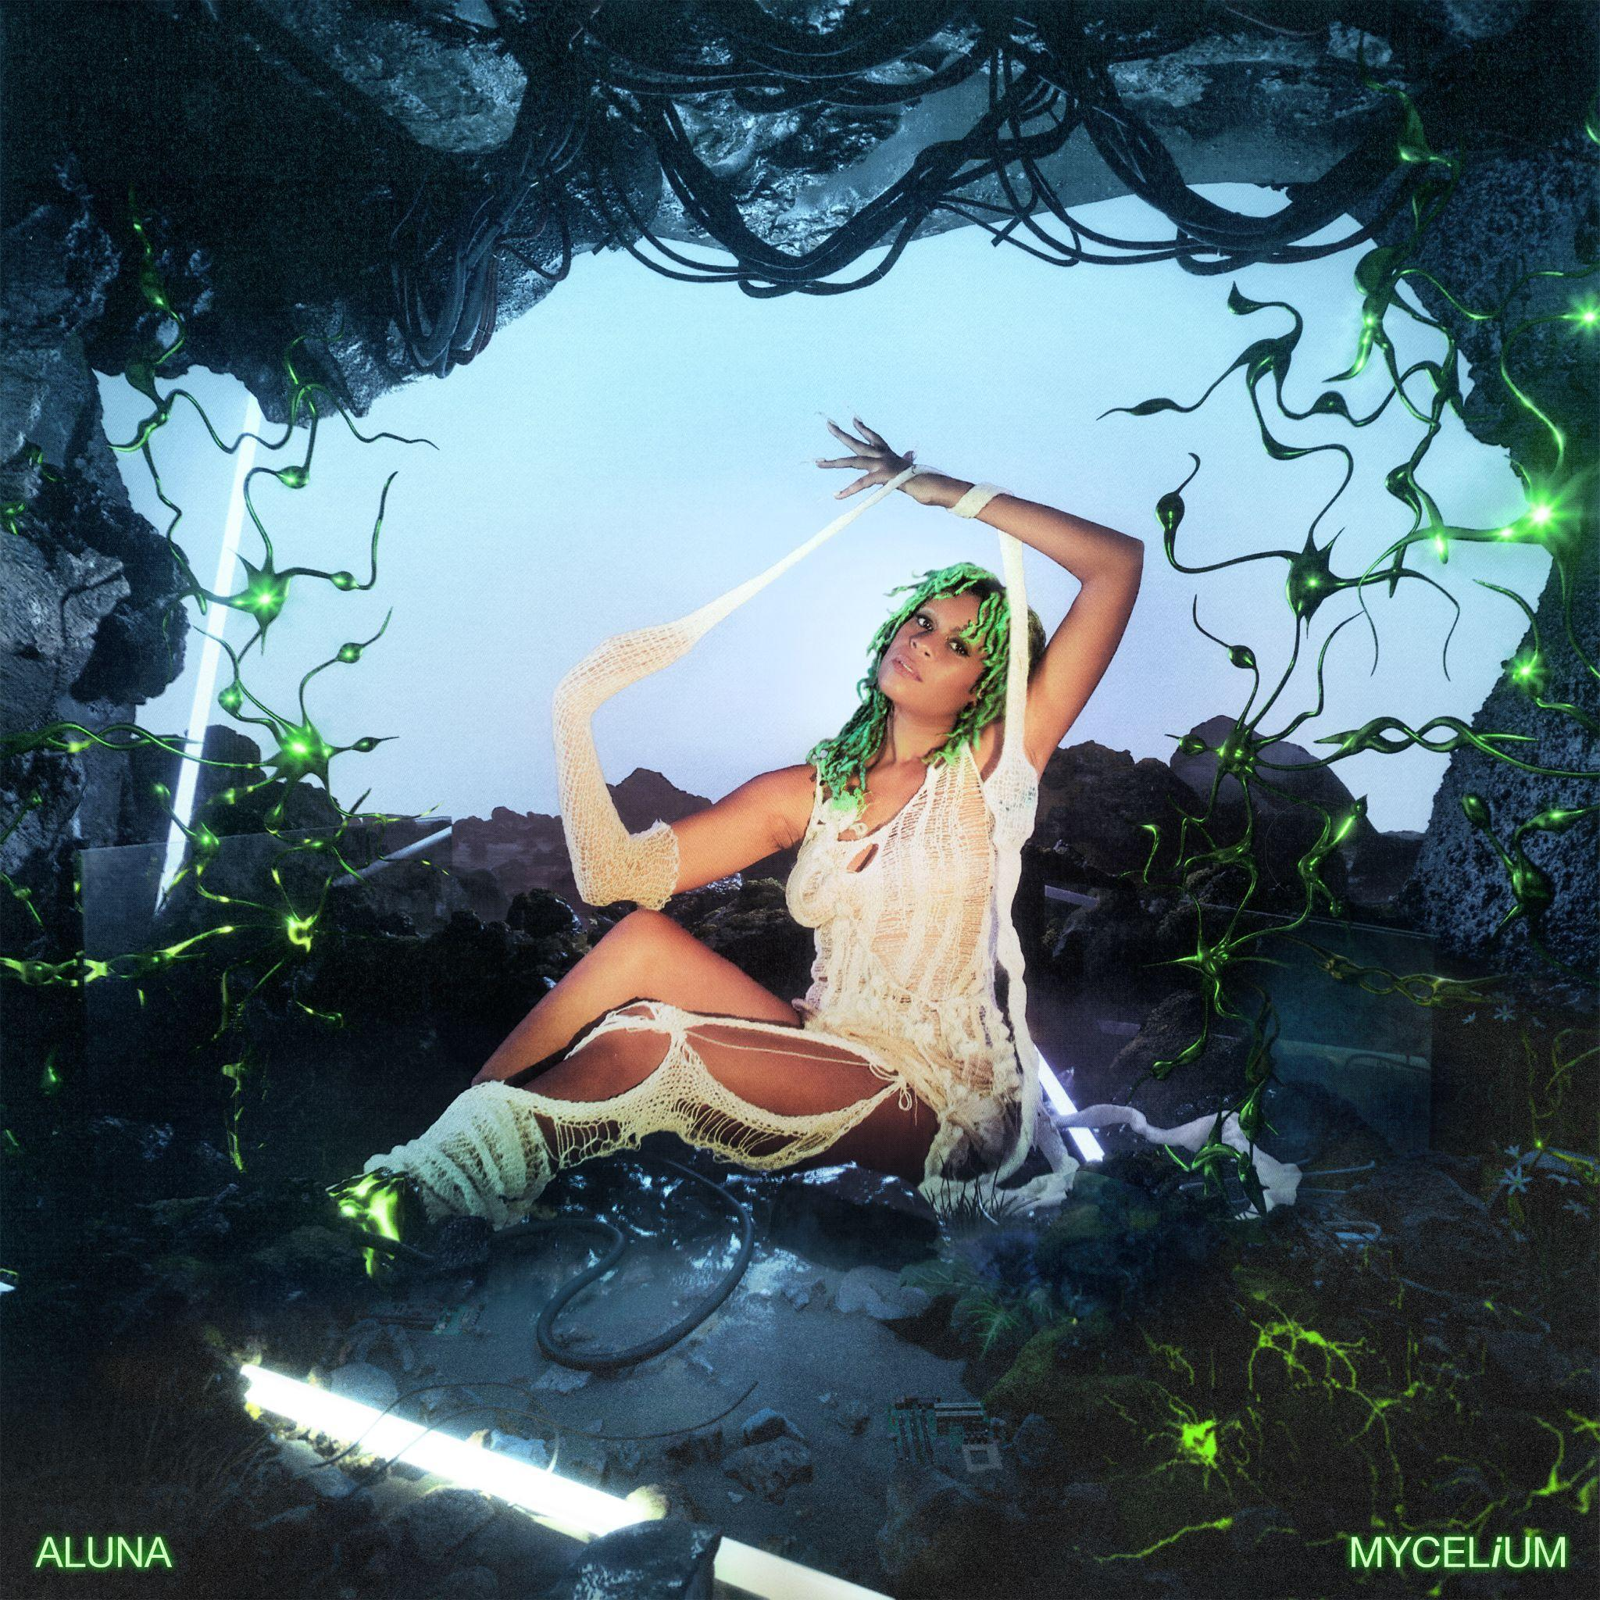

WEBSITE | INSTAGRAM | TWITTER | FACEBOOK | SPOTIFY | APPLE | SOUNDCLOUD | TIKTOK

About Aluna
Aluna originally got her start as one half of the beloved duo AlunaGeorge, achieving international renown with widespread acclaim, award nominations, major collaborations, and massive tours, but it wasn’t until later that she stepped truly into her power with her debut album Renaissance in 2020 (LISTEN) via Mad Decent/Because Music. Co-produced by Aluna alongside executive producer Lido, and featuring contributions from Princess Nokia, Jada Kingdom, SG Lewis, KAYTRANADA, Scott Storch, GRADES, Mr. Carmack and Rema, Renaissance represented the culmination of her journey of “a black girl in an all-white British suburb back in the day” to launching a rule-breaking revolution where rigid boundaries dissolve between culture, race, gender, and genre. Beyond generating over 100 million streams, it garnered widespread tastemaker acclaim. Pitchfork noted, “The album showcases her curatorial skills—honed from years of DJ sets, streaming playlists, and recently virtual shows as Aluna’s Room—and her range,” while Clash raved, “Renaissance sees Aluna cementing herself as one of the most exciting artists around with this iconic offering that will inspire dance records for years to come.” Now, Aluna gears up to further cement herself as one of the most important curators and voices in dance music with her second full-length solo offering, MYCELiUM [Mad Decent/Because Music] out now.

