SOUTH AFRICAN BREAKOUTS MAJOR LEAGUE DJZ AND MAJOR LAZER CONFIRM COLLABORATIVE AMAPIANO ALBUM PIANO REPUBLIK OUT MARCH 24
NEW TRACK “MAMGOBHOZI” FEATURING
BRENDA FASSIE DEBUTS
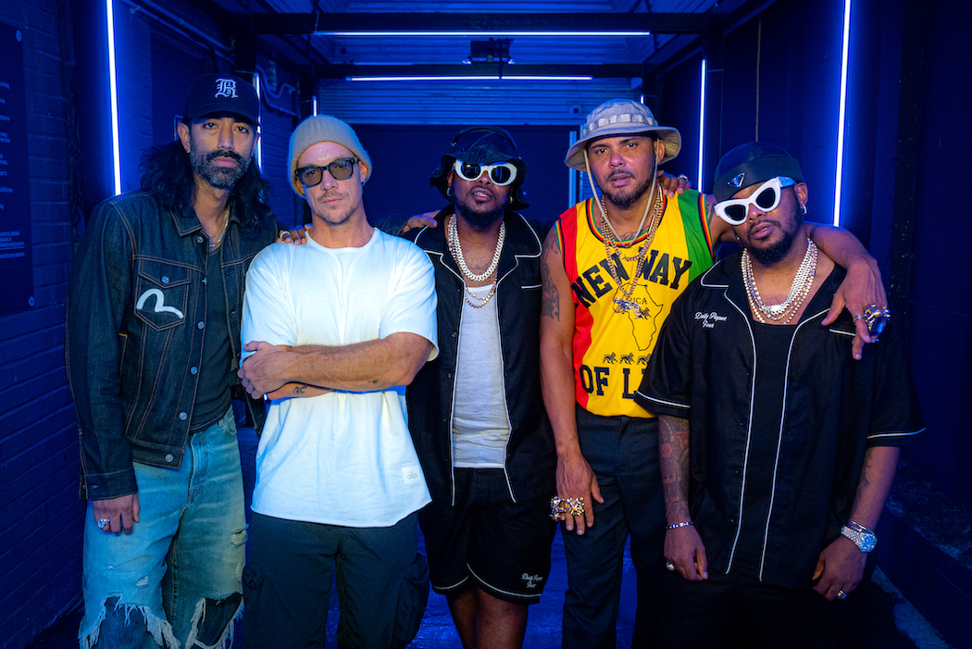
Press photo; credit: Joe Larkin
March 17, 2023—Piano Republik, the forthcoming collaborative album from emerging South African superstars Major League Djz and Major Lazer, is slated for release on March 24 via Mad Decent/Because—pre-order/pre-save it here. Today, the two groups share a new track, “Mambgobhozi,” which features a vocal sample from the late South African singer and activist Brenda Fassie’s “Vuli Ndlela”—listen here.
“Brenda Fassie was not only an icon, but she inspired many black South Africans to be their authentic selves,” Major League Djz say. “Her energy was infectious on and off the stage. Her music catalogue brought joy to the many South Africans that filled stadiums to see her perform and is a true reflection of South African history. ‘Vuli Ndlela’ is undoubtedly one of Brenda Fassie’s best bodies of work, holding the title of ‘Song of the Decade’ and a song we heard playing at every South African wedding and home then and now. It embodies the township sound of the late 90s, a true anthem as it celebrates a mother’s joy as her son gets married. Brenda Fassie knew how to narrate the African story, and her music catalogue speaks for her long after she has left us, a true force.”
The new track follows initial album offerings, “Designer” featuring Nigerian star Joeboy, and “Koo Koo Fun” featuring Nigerian icon Tiwa Savage and DJ Maphorisa, Major Lazer’s first new music since 2021 that features further contributions from Don Jazzy and Stargate. The track was later remixed by Bianca Costa, Chloé Caillet, Francis Mercier and Nic Fanciulli—listen here.
The music on Piano Republik falls under the genre of amapiano, a South African style of house music that emerged in 2012 and is descended from the South African house genre kwaito and Afrobeats. Pioneered largely by Major League Djz, amapiano is a hybrid of deep house, jazz and lounge music characterized by synths, airy pads and wide percussive basslines and is currently topping charts in the U.K. and beyond.
The BET-nominated amapiano duo Major League Djz—twin brothers Bandile and Banele Mbere—have quickly risen to international visibility as stars of the South African dance music scene, serving as pioneers of the genre and de facto global ambassadors with hits like “Bakwa Lah” and “Dinaledi.” Since the release of their critically acclaimed album from 2021, Outside, they have gone on to break the world record for the longest DJ set performed by a duo, performing for 75 hours for a special edition of their Balcony Mix Xperience. Last year, they performed at Coachella alongside Black Coffee and sold-out a headline show at the O2 Academy Brixton. With fans and supporters including TEMS, Burna Boy, Honey Dijon, Jorja Smith, Rema, Asake, Stefflon Don and Jayda G regularly attending their parties in South Africa, Ghana and beyond, they're now poised to take the world by storm.
Major Lazer is the global dance trio of Diplo, Walshy Fire and Ape Drums. Named for the group’s fictional figurehead, a one-armed Jamaican Zombie War commando, Major Lazer’s mission is to free the universe with music. The band has released four acclaimed albums, 2009’s Guns Don’t Kill People…Lazers Do, 2013’s Free The Universe, 2015’s Peace Is The Mission, featuring the Diamond-certified “Lean On” with DJ Snake and MØ—one of the most successful songs of all time—and 2020’s Music Is The Weapon, which features songs in five languages and collaborations with Nicki Minaj, J Balvin, Marcus Mumford, Khalid, Alessia Cara, Anitta, Paloma Mami, Busy Signal, BEAM, Shenseea, Nucleya and more.
MAJOR LEAGUE DJZ & MAJOR LAZER—PIANO REPUBLIK
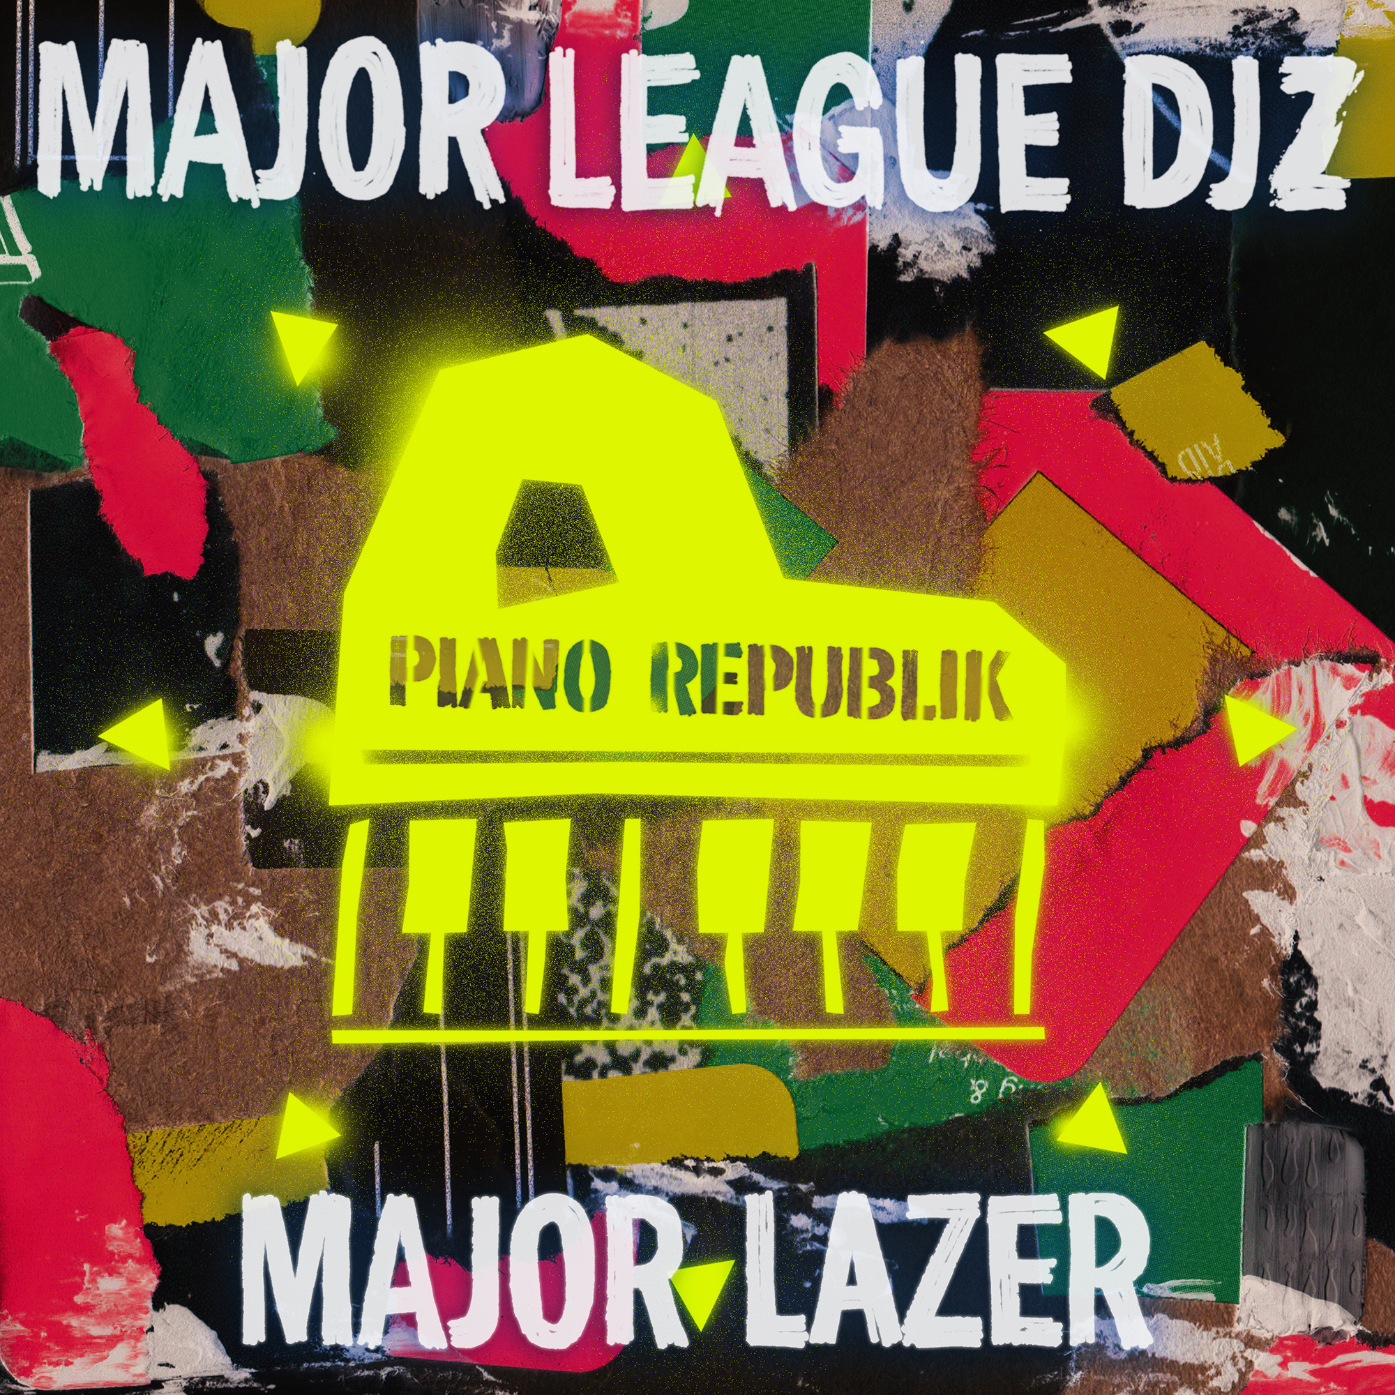
1. Smoking & Drinking feat. Ty Dolla $ign
2. Ke Shy feat. Tyla & LuuDaDeejay
3. Ngibambe feat. Gaba Cannal & Russell Zuma
4. Designer feat. Joeboy
5. Koo Koo Fun feat. Tiwa Savage & DJ Maphorisa
6. Mamgobhozi feat. Brenda Fassie
7. Oh Yeah feat. Ty Dolla $ign
8. Stop & Go feat. Msaki
9. Higher Ground ft. Boniface
For more information, please contact
Reid Kutrow, Ethan Jacobs or Carla Sacks at sacks & co., 212.741.1000, reid.kutrow@sacksco.com, ethan.jacobs@sacksco.com or
carla@sacksco.com.

