DENAI MOORE

SHARES NEW SINGLE “MOTHERLESS CHILD”
LISTEN HERE
WATCH VISUALISER HERE

MODERN DREAD OUT JULY 3RD ON BECAUSE MUSIC

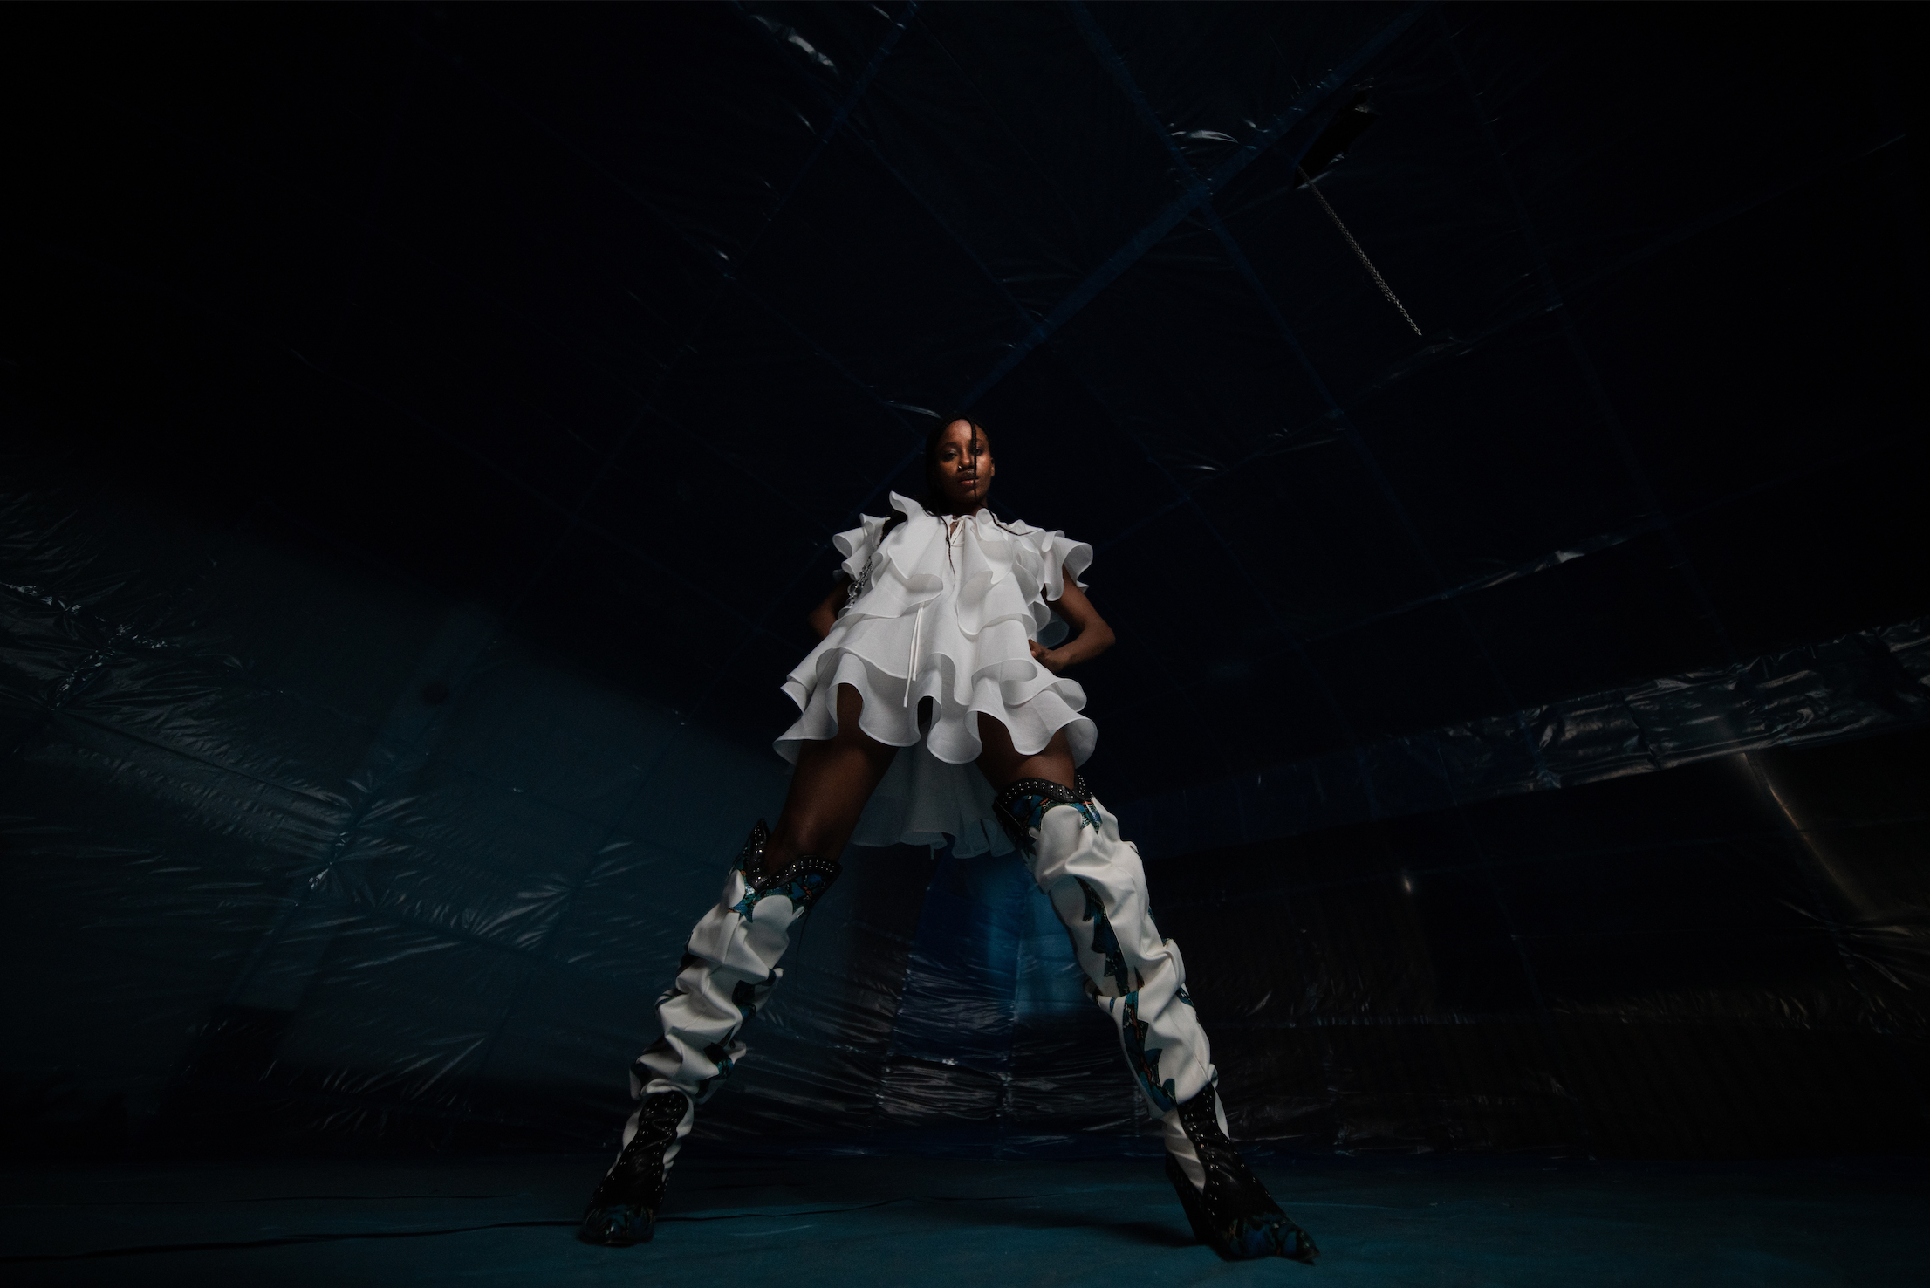
Credit: Nadira Amrani
-
“…this is the sound of an artist simply doing what feels good to them – and it works.” – Gay Times

“Denai Moore is the British soul artist rightfully taking her seat at the table” – Notion

Today, convention-defying singer/songwriter Denai Moore share’s new single “Motherless Child” from her highly anticipated forthcoming album Modern Dread out July 3 on Because Music. Moore digs deeper than ever before on this track and the result is some of her most nuanced song writing to date.

She says, “Motherless Child was a song that I wrote years ago that didn't work for other projects. Alex [Robertshaw] and I decided to revisit it and start completely from scratch, and then it suddenly felt much more fresh and exciting. This song is about detachment, loneliness & feeling really isolated from the world around me, which feels crazy releasing it in isolation during a pandemic.

The track comes accompanied by a 3D CG animated visualiser by George Jasper stone – as piece that a Moore explains represents “a warped shell of a human dancing on their own in a big space.”

Modern Dread is an album that sees Moore exploring personal demons whilst also voicing her concerns for the world at large, a daring exercise in micro versus macro that pays off richly in what is a dazzling step forward in artistry. It follows on from the critically hailed 2017 album “We Used to Bloom” and represents a delicious quantum leap in her career.

A unique blend of quixotic beats and introspective, sometimes harrowing songwriting which will undoubtedly stamp Moore as one of the most original talents we have around right now.

“To The Brink”, the first taster of Modern Dread, uses hair raising lyrics and gloriously rough edged vocals to push against the constant overload that we feel from every direction in society today. “Cascades” is equal parts nightmarish and surrealist, fantastical and bizarre as she sings about literally getting engulfed in sadness and depression, the sonic background shifts from optimistic to ominous, ending in a haunting, slowed down acapella outro.

LISTEN / WATCH “TO THE BRINK” HERE
LISTEN / WATCH “CASCADES” HERE

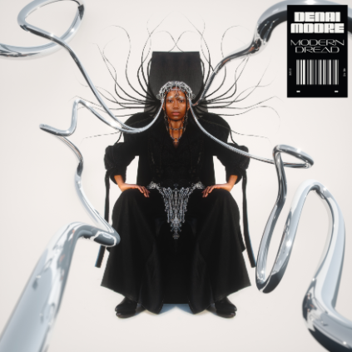

--
Denai Moore
Modern Dread
1. Too Close
2. Don’t Close The Door
3. Fake Sorry
4. Grapefruit
5. Cascades
6. Hail
7. To The Brink
8. Motherless Child
9. Turn Off The Radio
10. Honour
11. Slate
12. Offer Me
13. Wishing You Better
Pre-save here
Follow Denai Moore:
http://www.denaimoore.com/
https://www.instagram.com/denaimoore/?hl=en
https://twitter.com/DenaiMoore
https://www.facebook.com/DenaiMooreMusic/

